Поселения в Восточном Кормире

Realm of Wailing Fog

Thunder Peaks

Locations:

Creatures of the Thunder Peaks

Aurgloroasa the Sibilant Shade:

Rathyriak , Wizard of the Black Tower:

Mountains

Castlewall Mountain

Darkspear Mountain

Mount Draxiathas

Foralack Peak

Neiran’s Peak

Mount Nosgol

Gloraghon Mountain

Mount Thalagbror

Traflagar Mountain

Blackrock

Darkspear

Draxlathas

Fieron’s Fall

Flat Top

Foralack

Ulanthok

Castlewall

Granite Fist

Giant Reach Range

Gloraghon

Glimmerhorn

Grauthor’s Peak

Hammerfist

Highcrest

Nosgol

Overwatch

Rocknor

Stormwind

Trolltrack Hills

Neiran’s Peak

Thunder Mountain

Traflagar

Thalagbror

Wyverrn Peak

Storm Keep

Thunder Gap

Fauna

Flora

Inhabitants

Grimlocks

Dragons

The Thunder Peaks and the Storm Horns - Rumors

Masoner’s Bridge

West Hallack Way Post

East Hallack Way Post

Сандарлун (Thundarlun)

Eveningspire Estate

Castle Irlingstar

Пещера Bloodsworns

Havenmere

Notable Landmarks

Notable Characters

Winterhaven

Temples

Locations of Note

Important Characters

Other Notable Characters

Purple Dragons & War Wizards

Дворянские семейства:

Extinct Noble Houses

Important Organisations

Current Clack In Thunderstone

Sources

Immerford

Holborn

Ard Marie

Rivers

Immerflow

SARUUN KHEL

Sessrendale

Sessrenglade

Blade Keep

Hobgoblin camp

Организации

Орден «Братство»

Encounters in Eastern Cormyr

Encounters in Forest (Hullack)

Encounters in Mountains (Thunder Peaks)

# Realm of Wailing Fog

In the far eastern reaches of the Hullack forest lies the realm of Wailing Fog. This dark forest where the Hullack climbs into the foothills of the Thunder Peaks is among the most dangerous areas in all of Cormyr, home to bloodthirsty lycanthropes, raven-ous undead, and terrifying, unnatural beasts. The realm is ruled over by a mysterious coven of powerul hags.

Some scholars speculate that the fog that perpetually blankets the wood is not entirely natural, and may be linked to some extraplanar space that lies between this world and the Shadowfell. Many who have entered this realm have never returned while others have returned half-mad and raving about a mysterious vampire lord. Whatever this dreadful domain might be, adventurers are advised to excercise the utmost of caution in their travels to this area.

Sandwiched between the Hullack Forest and the Thunder Peaks, the Realm of Wailing Fog remains a land of desolate fens, ever-present mist, and eerie echoing calls. Even the Eldreth Veluuthra dare not explore the realm's long-ruined towers. Travelers to the region speak of a heavy feeling of "watchfulness" hanging over everything. Rumors persist that a coven of hags lives in the area, but these claims have never been substantiated.

# Thunder Peaks

Posted by Krash on the gleemax forum in response to **who 'owned' the Thuderpeaks before Cormyr?[1]** - at the bottom is an addedum from Markustay63 citing info from GHotR

The sources state that Cormyr is the first human kingdom north of the Lake of Dragons, with Marsember being the first permanent settlement in those parts being founded in -74 DR, a century before Cormyr is founded as a kingdom proper.

The scant information we have on Orva is found in the adventure "Four From Cormyr" (p.75). This information does not tell us whether Orva was a human kingdom or something else. For continuity's sake and given what we know of the far greater extent of forests in and around the present day Inner Sea lands, it is likely that Orva was an elven satellite kingdom, similar to the realm of Iliphar Nelnueve which was founded in -205 DR. The fact that the elven deity Labelas was worshipped there is likely proof enough of this but by far the best material to suport this contention is the "The Cormyrean Marshes" booklet (p.32) from the "Elminster's Ecologies" boxed set. This talks extensively about ancient elven-looking ruins in the Vast Swamp.

The reference in "Four From Cormyr" talks about Orva having existed "two millenia ago" (i.e. c. -630 to -650 DR or so). This predates Iliphar's kingdom by several centuries. I note that the Vast Swamp borders the Hullack Forest. Within the Hullack Forest is Elfhold which is detailed in "Faiths & Pantheons". The Elfhold is linked with Iliphar and his house, Amaratharr.

My thoughts are that Orva existed from around the -600s DR for a couple of centuries. House Amaratharr was a part of that realm until the king (likely a "laranlor" in elvish which means a monarch of a realm not powerful enough to consider labelling himself a "coronal") exhibited the tyrannical traits and 'delusions of empire' that led to the realm's demise. They likely fled back to Cormanthyr and told the coronal at the time, Tannivh Irithyl, what was going on. Before the elves could react, Orva became a hell-blasted ruin. The High Mages sent to bring this vassal realm to heel undertook the clean up work to seal the gate/portal between the region and the Nine Hells and to do what they could to ward the sourrounding lands from the evils that were created in the cataclysm.

As a reward for their loyalty, House Amaratharr and Iliphar were eventually granted the woodlands of Lythtlorn (the elven name for the Wolf Woods or what is now Cormyr - see Dragon#276, p.79).

Which brings us back to the Thunder Peaks. Before Cormyr, the whole region would have nominally been claimed by the elves of Cormanthyr and their satellite vassal kingdoms such as Orva and Arnothoi (see FRCS [2E]: A Grand Tour of the Realms, p.58 and a recent reference in Paul Kemp's short story in 'Realms of War'). In truth however the Thunder Peaks has always been dragon country. It's a running joke among a few of us FR fans and scholars that there are more dragons per square mile in the Thunder Peaks than anywhere else in the Realms.

By far the most formidable is the dracolich Aurgloaroasa "the Sibilant Shade" (see "Dragons of Faerûn" and the older 2E "Cult of the Dragon" sourcebooks) but there have been a host of others, mostly red. A possible reason they all clustered in the Thunder Peaks is that they were driven off or feared the mighty dragon Thauglor, suzerain of the lands of Cormyr and beyond until his defeat by Iliphar in -205 DR.

So in conclusion, the answer is Cormanthyr or one of its satellite, vassal elven realms depending on what historical period you refer to, but it would definitely be a situation of "claiming" rather than actually having a presence there and "ruling".[2]

*******************

Urd refugees from Darastrixhurt hi's built the first Kingdom in the Thunder Peaks. That would have occurred soon after the first Rage of Dragons, circa -25,000 DR[3].

Джерело: <[*http://forum.candlekeep.com/topic.asp?TOPIC_ID=9685&whichpage=4&SearchTerms=HIGHKNIGHTS*](http://forum.candlekeep.com/topic.asp?TOPIC_ID=9685&whichpage=4&SearchTerms=HIGHKNIGHTS)>

The southern end of the Thunder Peaks are known as the Marching Mountains in Archendale.

An orc horde poured out of the Thunder Pass 'nearly 350 years ago' to attack Deepingdale.

All info relating to Highdale is relevant with a few nice snippets of lore (hidden valleys with gnomes settlements etc).

Western Mistledale is plagued by 'numerous fell creatures' sweeping down from the Peaks, which suggests they breed unchecked in the mountains.

And to clarify the routes through the Peaks (

**The Thunder Way** is the road that links Cormyr and Sembia via Highdale, and passes through the **Thunder Gap**. The other route is via the**Thunder Pass** which links Cormyr with the Dalelands.

The Thunder Peaks are named for the sudden and devastating storms that batter them throughout the year. These wild and unsettled mountains are homes to large tribes of hobgoblins, goblins, their allies, and the under-mountain areas are known to hold tribes of orcs in some areas. These humanoids have no love for Cormyr, Sembia, and the Dalelands. Humanoids are known to raid human settlements despite patrols of Purple Dragon and other local forces. Travelers are advised to go armed, and wary.

The mountain passes are blocked in the winter by snow. Inclement weather in the Thunder Peaks make mining operations difficult, though solitary prospectors sometimes return with fist-sized silver nuggets; however, many never return at all. Since the plains and foothills of the middle-western region of the Thunder Peaks have been occupied by the Covenant of the Blade and Purple Dragon forces, Cormyr now considers the Thunder Peaks as it’s eastern-most border.

In the northern Thunder Peaks, a Red Dragon is believed to call that area home, but has not been seen for many years. Local lore holds that through the years adventures exploring the ancient dwarven city of Thunder-Holme have encountered a dracolich named Aurgloroasa the Sibilant Shade.

The southern Thunder Peaks was previously controlled by a powerful cloud giant named The Storm King. The Storm King held sway over the hobgoblin and goblin clans controlling that area. The Storm King was defeated by the Covenant of the Blade in Tarsakh of Storms, DR 1365.

Description:

The Thunder Peaks are named for the sudden and devastating storms that batter them throughout the year. These wild and unsettled mountains are homes to large tribes of hobgoblins, goblins, their allies, and the under-mountain areas are known to hold tribes of orcs in some areas. These humanoids have no love for Cormyr, Sembia, and the Dalelands. Humanoids are known to raid human settlements despite patrols of Purple Dragon and other local forces. Travelers are advised to go armed, and wary.

The mountain passes are blocked in the winter by snow. Inclement weather in the Thunder Peaks make mining operations difficult, though solitary prospectors sometimes return with fist-sized silver nuggets; however, many never return at all. Since the plains and foothills of the middle-western region of the Thunder Peaks have been occupied by the Covenant of the Blade and Purple Dragon forces, Cormyr now considers the Thunder Peaks as it’s eastern-most border.

In the northern Thunder Peaks, a Red Dragon is believed to call that area home, but has not been seen for many years. Local lore holds that through the years adventures exploring the ancient dwarven city of Thunder-Holme have encountered a dracolich named Aurgloroasa the Sibilant Shade.

The southern Thunder Peaks was previously controlled by a powerful cloud giant named The Storm King. The Storm King held sway over the hobgoblin and goblin clans controlling that area. The Storm King was defeated by the Covenant of the Blade in Tarsakh of Storms, DR 1365.

**Creatures of the Thunder Peaks:**

From the Nothern Thunder Peaks near Shadow Gap to the Southern Thunder Peaks near Saerb, the Thunder Peaks are the home for numerous land based animals, such as countless small burrowing creatures, aurumvorax, black bears, cave bears, brown bears, mountain lions, red sheep, wild yaks, mountain lions, wolves.

Winged creatures including countless types birds, hawks, eagles, aarakocra, vultures, and larger creatures such as perytons, griffons, hippogryphs, find home in the Thunder Peaks.

Powerful creatures like basilisks, chimerae, displacer beasts, and minotaur lizards call Thunder Peaks home as well.

For humanoids, the **Northern Thunder Peaks** north of Tilverton are controlled by orcs and kobolds, while the Central and Southern Thunder Peaks have been held for generations by hobgoblins and goblin clans. Bugbears, ogres, dopplegangers, ettins, fomorian giants, hill giants, mountain giants, and stone giants live among the humanoids, allying themselves with powerful clans or forging their own homeland if in large enough groups. Troglodytes have been encountered in deep caverns in the Thunder Peaks. A small clan of good-natured cloud giants are believed to live on a castle high on the northern side of **Traflagar Mountain**.

Powerful, unique denizens also call the Thunder Peaks home, a few that are know are listed below:

### Aurgloroasa the Sibilant Shade

Aurgloroasa is an ancient dracolich of legend, which is believed to lair in somewhere in the Central or Southern Thunder Peaks. Aurgloroasa has last been seen by adventurers of old in her true form, but since she is very powerful and undead, is believed to still be haunting the Thunder Peaks somewhere. It is believed that she leaves the Thunder Peaks in disguise, never in her true form. Bard tales across the Inner Sea speak of her power, capability of destruction, and vast wealth. Se is believed to be the destroyer of the black dragon, Arngalor, over the skies of Archendale, in 1299 DR.

### Nevalarich:

Nevalarich is an old red drake which calls the Central Thunder Peaks his home. His lair is believed to be on the east side of the Thunder Peaks in the northern central portion, and has been known to raid lands to the east far and wide, staying clear of Cormyr and Sembia. Nevalarich has not been seen in human lands for many years, but it is feared he still resides in his lair, sleeping.

Rathyriak , Wizard of the Black Tower: A large, black-stone tower rises on the northwest side of Neiran’s Peak. It is believed to be the home of a reclusive and powerful wizard known only as “Rathyriak”. Not much is known of Rathyriak, besides he does not come from the Inner Sea, is reclusive, does not like visitors, and the denizens of the Thunder Peaks stay their distance from his tower. It is believed Rathyriak’s tower is guarded by numerous, magical created constructs and other creatures.

### Storm King:

The Storm King was a powerful Cloud Giant that controlled the south-eastern portion of the Southern Thunder Peaks for generations, and ruled over numerous clans of hobgoblins and goblins. In the spring of 1365 DR, the Covenant of the Blade defeated the Storm King’s apprentice and his allies in a great battle at his fortress in Castle Cliff Mountain, now called Storm Keep. The Storm King’s apprentice had defeated his master with the help of a powerful adventuring band, and took the mantle of the Storm King, only to be defeated by the COB.

### Tarlacoal:

Tarlacoal is a gold dragon that is believed to call the Thunder Peaks his home. Not much is known of Tarlacoal, except the fact it is believed he spends most of his time in human form, interfering in Inner Sea politics in an effort to champion good causes by manipulating political events throughout the Dalelands, Cormyr, and Sembia. It is believed it was Tarlacoal the whispered in Azoun Obarskyr IV’s ear during the rise of Gondegal, “the Lost King”, which persuaded him to personally lead the attack against Gondegal when he claimed Arabel as the capital of his new kingdom. Gondegal was created the his unnamed kingdom in the Year of the Dragon, 1352 DR, with Arabel the capital. Gondegal ruled for less than a season, ending when King Azoun IV and a mighty host of Purple Dragons marched on his army, which melted away overnight before the battle was ever fought. The location of Tarlacoal’s lair is unknown, and he is believed to be an old and powerful dragon.

## Locations:

### Castlewall Mountain:

Castlewall mountain is so named do to its natural protections towards its peak. A tall mountain in the range, though not the tallest, the mountain is surrounded by cliff walls on its west, north, and east sides between 200 and 300 tall of sheer cliff faces about 2,000 feet from its peak. On its southern side, a huge crevice divides itself from Mount Draxlathias, with the crevice dropping thousands of feet to a rocky river valley below. It is on the southern side of this mountain peak on the edge of the crevice that Storm Keep is located.

### Darkspear Mountain, Mount Draxiathas, Foralack Peak:

These high mountains on the south-eastern side of the mountain range are controlled by numerous hobgoblin clans, their allies, and other humanoids that were once considered part of the Storm King’s personal army. Since his fall in 1364-1365 DR, these humanoids have a very shaky truce with one another.

### Neiran’s Peak:

 A tall solitary peak on the central west side of the Thunder Peaks on the north side of the Thunder Gap. The Black Tower is located on the northwest side and toward the base of this mountain peak.

### Mount Nosgol:

Located in the south-western part of the mountain range. Mount Nosgol is a medium-height mountain in the range, surrounded on its south side by numerous foothills. A clan of Hobgoblins, the burning sky tribe, ruled by Klug the Great, calls this mountain home.

### Gloraghon Mountain:

This mountain is located in the South Thunder Peaks, on the eastern side bordering Deepingdale and Archendale. Gloraghon Mountain is the residence of a few powerful hobgoblin clans that hold sway over goblinoids that can swarm out of the mountain in numbers. One of the clans, the “Blood Spear” clan, took heavy casualties in an attack on Deepingdale at the hands of the Covenant of the Blade and their allies in the Spring of 1365 DR. Their fortress was a large keep guarding the gates of a cavern complex, facing Mount Thalagbror.

### Mount Thalagbror:

Mount Thalagbror is a mid0sized mountain peak on the eastern side of the Sounthern Thunder Peaks on the border of Deepingdale and Archendale. It is named for an evil ogre mage that terrorized Archendale hundreds of years ago. It is currently controlled by hobgoblins, goblins, and other creatures that occasionally leave the mountains to raid nearby human settlements.

### Traflagar Mountain:

A high-peak on the southwestern side of the mountain range, Traflager Mountain is know to have numerous crevices, valleys, and streams. It is a favorite place of humanoids, and is rumored to have deep caverns. The north-side of the mountain peak, far from the reach of the creatures below, is a giant sized castle facing to the north, rumored to be the home of a family of Cloud Giants.

Джерело[4]: < >

Thunder Peaks

The Thunder Peaks

Races Goblins, orcs

Locations in the Thunder PeaksSettlements in the Thunder PeaksMountains in the Thunder Peaks

Items from the Thunder Peaks

The Thunder Peaks were a range of mountains that ran in a north–south line, marking the eastern edge of Cormyr. The entire range was subject to extremely severe and sudden storms all year round. They were home to tribes of orcs and goblins that launched raids in nearby Cormyr, Sembia, and the Dalelands, and were also home to the dracolich **Aurgloroasa**, the Sibilant Shade. The Thunder Peaks once hosted the dwarven settlement of Thunderholme.[2]

The Thunder River flowed west out of the Thunder Peaks to the Wyvernwater. In Elven, the Thunder Peaks were called **Airmbult**, or translated into common, Storm-Fangs.[3]

Florae

The mountains had a number of unique species of plants including the turis[4] and kirin trees as well as Bowen's flowers.[5] The scent of the heavily aromatic ateris plants would blow down to the town of Tilverton with strong winds.[4]

Notable Location

The Iron Maidens, a band of female-only mercenaries, had its fortress in a formerly deserted castle hidden somewhere in the mountains.[6][5]

## Creatures of the Thunder Peaks

From the Nothern Thunder Peaks near Shadow Gap to the Southern Thunder Peaks near Saerb, the Thunder Peaks are the home for **numerous land based animals, such as countless small burrowing creatures, aurumvorax, black bears, cave bears, brown bears, mountain lions, red sheep, wild yaks, mountain lions, wolves**.

Winged creatures including countless types **birds, hawks, eagles, aarakocra, vultures, and larger creatures such as perytons, griffons, hippogryphs**, find home in the Thunder Peaks.

Powerful creatures like basilisks, chimerae, displacer beasts, and minotaur lizards call Thunder Peaks home as well.

For humanoids, the Northern Thunder Peaks north of Tilverton are controlled by orcs and kobolds, while the Central and Southern Thunder Peaks have been held for generations by hobgoblins and goblin clans. Bugbears, ogres, dopplegangers, ettins, fomorian giants, hill giants, mountain giants, and stone giants live among the humanoids, allying themselves with powerful clans or forging their own homeland if in large enough groups. Troglodytes have been encountered in deep caverns in the Thunder Peaks. A small clan of good-natured cloud giants are believed to live on a castle high on the northern side of Traflagar Mountain.

Powerful, unique denizens also call the Thunder Peaks home, a few that are know are listed below:

## Aurgloroasa the Sibilant Shade:

Aurgloroasa is an ancient dracolich of legend, which is believed to lair in somewhere in the Central or Southern Thunder Peaks. Aurgloroasa has last been seen by adventurers of old in her true form, but since she is very powerful and undead, is believed to still be haunting the Thunder Peaks somewhere. It is believed that she leaves the Thunder Peaks in disguise, never in her true form. Bard tales across the Inner Sea speak of her power, capability of destruction, and vast wealth. Se is believed to be the destroyer of the black dragon, Arngalor, over the skies of Archendale, in 1299 DR.

Nevalarich: Nevalarich is an old red drake which calls the Central Thunder Peaks his home. His lair is believed to be on the east side of the Thunder Peaks in the northern central portion, and has been known to raid lands to the east far and wide, staying clear of Cormyr and Sembia. Nevalarich has not been seen in human lands for many years, but it is feared he still resides in his lair, sleeping.

## Rathyriak , Wizard of the Black Tower:

A large, black-stone tower rises on the northwest side of Neiran’s Peak. It is believed to be the home of a reclusive and powerful wizard known only as “Rathyriak”. Not much is known of Rathyriak, besides he does not come from the Inner Sea, is reclusive, does not like visitors, and the denizens of the Thunder Peaks stay their distance from his tower. It is believed Rathyriak’s tower is guarded by numerous, magical created constructs and other creatures.

### Storm King:

The Storm King was a powerful Cloud Giant that controlled the south-eastern portion of the Southern Thunder Peaks for generations, and ruled over numerous clans of hobgoblins and goblins. In the spring of 1365 DR, the Covenant of the Blade defeated the Storm King’s apprentice and his allies in a great battle at his fortress in Castle Cliff Mountain, now called Storm Keep. The Storm King’s apprentice had defeated his master with the help of a powerful adventuring band, and took the mantle of the Storm King, only to be defeated by the COB.

### Tarlacoal:

Tarlacoal is a gold dragon that is believed to call the Thunder Peaks his home. Not much is known of Tarlacoal, except the fact it is believed he spends most of his time in human form, interfering in Inner Sea politics in an effort to champion good causes by manipulating political events throughout the Dalelands, Cormyr, and Sembia. It is believed it was Tarlacoal the whispered in Azoun Obarskyr IV’s ear during the rise of Gondegal, “the Lost King”, which persuaded him to personally lead the attack against Gondegal when he claimed Arabel as the capital of his new kingdom. Gondegal was created the his unnamed kingdom in the Year of the Dragon, 1352 DR, with Arabel the capital. Gondegal ruled for less than a season, ending when King Azoun IV and a mighty host of Purple Dragons marched on his army, which melted away overnight before the battle was ever fought. The location of Tarlacoal’s lair is unknown, and he is believed to be an old and powerful dragon.

# Mountains

## Castlewall Mountain

Castlewall mountain is so named do to its natural protections towards its peak. A tall mountain in the range, though not the tallest, the mountain is surrounded by cliff walls on its west, north, and east sides between 200 and 300 tall of sheer cliff faces about 2,000 feet from its peak. On its southern side, a huge crevice divides itself from Mount Draxlathias, with the crevice dropping thousands of feet to a rocky river valley below. It is on the southern side of this mountain peak on the edge of the crevice that Storm Keep is located.

## Darkspear Mountain

## Mount Draxiathas

## Foralack Peak

These high mountains on the south-eastern side of the mountain range are controlled by numerous hobgoblin clans, their allies, and other humanoids that were once considered part of the Storm King’s personal army. Since his fall in 1364-1365 DR, these humanoids have a very shaky truce with one another.

## Neiran’s Peak

A tall solitary peak on the central west side of the Thunder Peaks on the north side of the Thunder Gap. The Black Tower is located on the northwest side and toward the base of this mountain peak.

## Mount Nosgol

Located in the south-western part of the mountain range. Mount Nosgol is a medium-height mountain in the range, surrounded on its south side by numerous foothills. A clan of Hobgoblins, the burning sky tribe, ruled by Klug the Great, calls this mountain home.

## Gloraghon Mountain

This mountain is located in the South Thunder Peaks, on the eastern side bordering Deepingdale and Archendale. Gloraghon Mountain is the residence of a few powerful hobgoblin clans that hold sway over goblinoids that can swarm out of the mountain in numbers. One of the clans, the “Blood Spear” clan, took heavy casualties in an attack on Deepingdale at the hands of the Covenant of the Blade and their allies in the Spring of 1365 DR. Their fortress was a large keep guarding the gates of a cavern complex, facing Mount Thalagbror.

## Mount Thalagbror

Mount Thalagbror is a mid0sized mountain peak on the eastern side of the Sounthern Thunder Peaks on the border of Deepingdale and Archendale. It is named for an evil ogre mage that terrorized Archendale hundreds of years ago. It is currently controlled by hobgoblins, goblins, and other creatures that occasionally leave the mountains to raid nearby human settlements.

## Traflagar Mountain

A high-peak on the southwestern side of the mountain range, Traflager Mountain is know to have numerous crevices, valleys, and streams. It is a favorite place of humanoids, and is rumored to have deep caverns. The north-side of the mountain peak, far from the reach of the creatures below, is a giant sized castle facing to the north, rumored to be the home of a family of Cloud Giants.

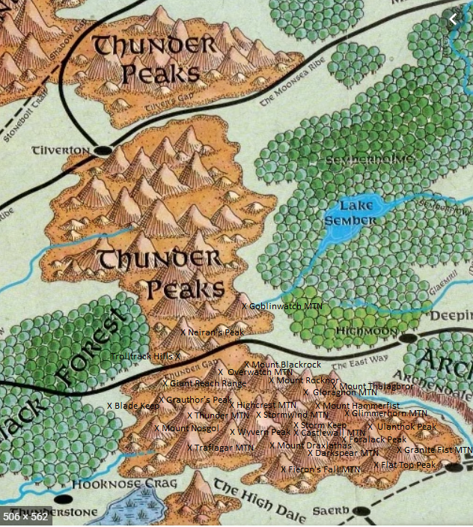

## Blackrock

## Darkspear

## Draxlathas

## Fieron’s Fall

## Flat Top

## Foralack

## Ulanthok

## Castlewall

## Granite Fist

## Giant Reach Range

## Gloraghon

## Glimmerhorn

## Grauthor’s Peak

## Hammerfist

## Highcrest

## Nosgol

## Overwatch

## Rocknor

## Stormwind

## Trolltrack Hills

## Neiran’s Peak

## Thunder Mountain

## Traflagar

## Thalagbror

## Wyverrn Peak

## Storm Keep

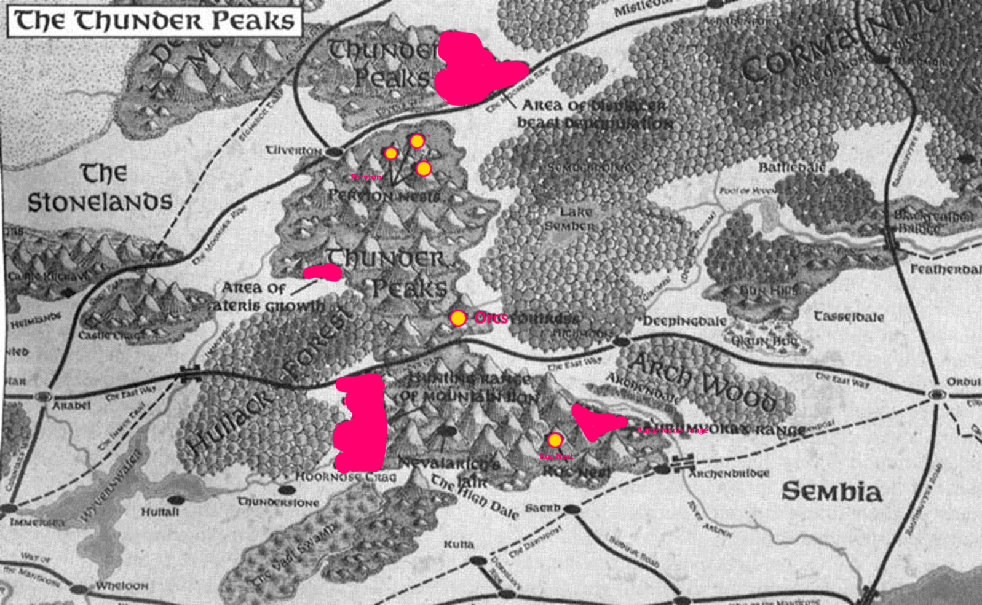Source[6] On map: Mountain lions, Roc, Aurumvorax, Displacer Beast, Perytonds

## Thunder Gap

This is the only practical passage through the Thunder Peaks between the High Dale and Tilver's Gap. There is a fort here to guard the passage. A 30-foot high stone wall spans the pass now and a garrison of Purple Dragons guards the one gate through it. The wall was built as a defense against Sembia and for a while became less strategically important since Sembia was defeated and occupied. Now, with the resurgence of the Drow in Cormanthor the garrison is quickly increasing in importance. The pass is closed to access by land from about mid-Marpenoth to the beginning of Tarsakh each winter due to the severe weather. The fort and garrison is maintained in these months through teleportation magic, although there is not yet any gate or portal established here.

## Fauna

### Red Sheep

One of the more unusual creatures of this ilk is the red, sheep, so called because of the red-brown tint to its woolly hair. It's usually found in the Thunder Peaks.

These are bizarre crosses between sheep and goats. They eat plants, but they have been known to eat cooked meat. They never have been seen eating raw meat, however. A large herd of red sheep lives in the Thunder Peaks along the banks of the Semberflow. Travelers to the area note that hundreds of red sheep can be seen at one time, all crowding for the lush greenery that grows along the river banks. When approached, the herd will bolt quickly back into the Thunder Peaks, seeking the sheerest face they can. With startling nimbleness, they scale the face and take refuge on the smallest of ledges.

Alas, they are truthfully easy to hunt, for a crossbow bolt or well-aimed arrow can seek out even the most inaccessible red sheep. Once they find their ledge, they seem unwilling to move any farther away, feeling their sanctuary safe enough. These unmoving targets are easy shots for even novice archers. The hair of red sheep is extremely coarse and tough, almost to the point of being woolen. Their coat is wonderful material for winter cloaks and other protective clothing. It is warm, easy to weave into cloth when using the proper techniques, and (unlike common sheep's wool) does not smell when wet. More, it is unusually resistant to moisture. Red sheep blankets are also very popular, and they are sold in quantity in Tilverton.

### Wild Yaks

The wild yak is another unusual creature inhabiting the Thunder Peaks. The yak resides mostly in the northern reaches of the Thunder Peaks, north of Tilver's Gap. They are also found in the higher peaks and in the southern Thunder Peaks as well.

I make the distinction between the wild yak and the domestic yak because there are significant differences between them. The yak is not usually found in either mountain range, so it is odd for domestic ones to be encountered here. Yet farmers in Thunderstone and Kulta swear by their animals, claiming they are superior beasts of burden. These domesticated yaks are very calm and sedate and do indeed make placid carriers.

But the yaks found in the peaks, those untainted by the influence of civilization, are wild beasts with fire in their hearts. They are not wont to investigate new things or wander into campsites. They stick to themselves and consider anything as big or bigger than they are a threat. When confronted, which to them could amount to a traveler merely standing on a hillside looking at the herd, the entire group of yaks, outnumbered or not, will charge to attack.

Their large horns and their practiced, nimble footing on rocky terrain make them a real threat to people. Once the charge is begun, any number of things could happen. The yaks could charge and not stop, throwing themselves toward the threat with abandon. They could charge just once, then flee with great speed, or they may charge, wait, then charge again. Yak behavior has been difficult for me to grasp, even after hearing numerous eyewitness accounts of their attacks.

Wild yaks change their locale with the season. During summer, they stick to the highest areas of the peaks, trying to find snow. They eat whatever grows there and will also venture downhill to where lush plants are, but only during the cooler dusk and dawn hours. For the winter, they go to the warmer valleys in the Thunder Peaks and sometimes travel along the banks of whatever streams are still flowing.The wild yak has a thick fur coat that is highly protective. It is extremely warm and enables the yak to survive blizzards with relative ease. When caught in a blizzard, the yak will turn so its hind end faces the direction of the wind, whereupon it merely waits until the wind dies down and then continues on its way.

This behavior, even present in domesticated yaks, has resulted in the saying of "go yakward" and variations of it among the folks of Thunderstone and Kulta. It has come to mean "avoid danger or unpleasantness." It is also used to refer to town leaders who refuse to see the farmers' point of view or who seem to ignore impending issues. When that happens, the farmers start talking about the "yaks" in office

### Hippogriffs

Obviously related in some strange way to griffons, these are crosses between eagles and horses. They are more tolerated, for they present less of a threat to civilization around the Thunder Peaks, which is where the strongest concentration of hippogriffs seems to be. It is believed that a herd of hippogriffs lives somewhere close to the source of the Immerflow River, which winds through the Thunder Peaks.

These creatures are more sought after as winged mounts than griffons, as the calmer nature of the hippogriff means easier training and more competent and trustworthy beasts to ride upon.

It was some years ago that I heard King Azoun owned a hippogriff mount. Still, I have not heard any news about it recently, so I do not know if it still exists, if it suffered some accident, or if it was forgotten about by the king and sold to someone else.

The Purple Dragons have taken a keen interest in the hippogriffs and are making a concentrated effort to secure enough young ones to make a special troop of winged mounted Purple Dragons. This force would be used to respond quickly to raids and, more likely, to serve as messengers between Suzail and locations on Cormyr's borders like High Horn and Tilverton. I am certain that the Purple Dragons know the location of the hippogriff herd, but they are jealously guarding that secret.

### Perytons

This foul cross between eagle and stag is a menace in the northern regions of the Thunder Peaks. These avians actively seek humanoid prey, particularly humans.

The perytons are fond of attacking caravans that pass through Tilver's Gap. In fact, it is not too uncommon for a large caravan to be attacked multiple times by perytons from different nests.

The peryton threat, combined with that of the occasional griffon attacks closer to Gnoll Pass, has made traveling from Arabel to parts east rather dangerous. This has increased the drive to have a special troop of wing-mounted Purple Dragons, described previously.

The fact that perytons cannot be harmed by weapons that aren't magically enchanted increases their threat to everyone. Perytons have been very selective in establishing their nests. They are careful to avoid contact with other winged creatures, even though they have no natural predators to be concerned about. They are using their intelligence to ensure that they have an unobstructed path to their prey and that their hunts will be made with minimal interference by others. It is because of this that the perytons are thought to have nested over Tilver's Gap instead of closer to Castle Crag. They do not want to compete with the griffons for food, nor do they want to attack prey that is constantly on guard for ambush by other winged predators.

Elminster's Notes: Interested readers may wish to reference the "Peryton" entry in the booklet about the Great Gray Land of Thar, there to read Talyssa Strongbow's insightful commentary.

### Rocs

This gargantuan bird is, according to my research, exclusive to warmer climes than what is usually found in either the Storm Horns or Thunder Peaks. Still, I believe a reason for their presence so far north of their usual habitat is yet to be found.

Rocs are sometimes tamed by giants: storm and cloud giants specifically, for various reasons. I know of at least one group of giants in the southern regions of the Thunder Peaks and I theorize that this group has or had a male and female roc with them. Perhaps those rocs made their escape or were let loose, but now for certain a nest (likely only one) of them lives in the Thunder Peaks.

I was living near Thunderstone when I heard stories of huge birds swooping down upon herds near Kulta. At first it was feared that hippogriffs from up north had come down south, but as reliable descriptions came in I knew it had to be rocs that were on the hunt.

They have tremendous appetites, especially where young are present. For this reason, I feared a quick depletion of the area's livestock. I decided to make an expedition into the Thunder Peaks to see if taking a mercenary force to the roc nest would be feasible. I found the location of their massive nest with surprisingly little difficulty. The nest was composed of whole trees.

I beheld a sad sight. Although rocs are a threat to our livelihood and are dangerous, they are majestic creatures worthy of admiration and respect. The nest had only two rocs, a male and female, which were in pitiful shape. They looked to be suffering from some sickness, for their feathers were matted and falling out. Their eyes, each as big as my chest, were dull and lifeless. I crept up to them and they made no effort to repel me from their nest. I examined them closer, and saw several half-eaten cattle and horse carcasses. I surmised that someone had tainted or cursed their own livestock and set some out as bait for these birds, hoping that they would eat them and become sick and die. Although a clever plot, the result was a loss to nature.

Taking pity on them, I healed them magically, though my skills weren't enough to allow the massive animals to recover completely.

### Chimerae

We classify this multiheaded creature as pawed, due to its leonine forequarters. The hindquarters of the chimera are those of a large goat. The chimera has three heads: a goat's, a lion's, and a dragon's.

Chimerae lurk only in **the deepest lairs of the Storm Horns**. They are known in the Thunder Peaks, but more of them seem to live in the western mountain range. The dragon head of the chimera influences the whole creature to live in a subterranean environment, while the lion head urges the creature to leave its lair and hunt for prey wherever it can find it. For this reason, chimerae may be encountered anywhere within a cavernous structure in a mountain range.

It is not unheard of for a chimera to make its way outside a mountain and search for prey on the surface. However, since the chimera is an omnivore and adaptable, it will eat vegetation when there is no meat available. The main motivation for leaving a mountain or venturing close to the surface would be influence from one of the other heads - most likely the lion.

Once on the surface, the dragon head influences the others to allow it to use its wings to take to the air, and from there the dragon and lion heads cooperate in hunting for prey. The chimerae do have a language, but no one to my knowledge has tried to communicate with them to any extent.

### Displacer Beasts

These green-eyed, six-legged panthers of death have had surges of terrible activity in the Thunder Peaks north of Tilver's Gap. Even a raiding party based in that section of the range has a heraldic-styled displacer beast as its symbol.

No one is certain how, but a few years ago displacer beasts were introduced into that area. They started traveling throughout the range between the Moonsea Ride and the Northride. Because of this, the region has a much lower population of natural life than it would normally have, with the exception of winged creatures which have been able to escape the wrath of the displacer beast.

All animals smaller than a displacer beast, which is generally 10-12 feet long and 500 pounds, were hunted with a vengeance. For this reason, many have theorized that the introduction of displacer beasts was done for a specific purpose - to clear the area. But why anyone or any group would want to accomplish such a task is yet unknown.

## Flora

The amount and diversity of growth on the mountains is great. A number of factors influence what grows where, but each plant serves some function in the ecosystem.

The greatest factor when discussing plant life in the mountains is the altitude. In general, the higher the altitude, the less plant life one is likely to encounter.

At lower altitudes, the plant life basically resembles that of the surrounding non-mountainous environment. **The Thunder Peaks near Hullack Forest are themselves heavily forested up to the timberline.** In fact, were it not for the gradually steepening grade, a traveler would never realize that a mountain was being walked upon. Likewise, the Storm Horns - next to the Farsea Marshes - teem with species that do not require the rich swamp environment and can survive on the comparatively arid soil of the mountains.

**Above the timberline, which is generally the point at which only moss and tundra grow, sometimes inch-high flowers are found. Each stage of altitude has plants unique to that level. As the altitude becomes greater, the size and frequency of plants decreases. Trees become smaller, especially those close to the timberline, and plants become tiny.**

### Notable Plant Products

Many plants found in the mountains are not generally located in other areas. The reason they grow so well on the mountains is because of the thinner air and increased exposure to sunlight.

#### Bowen's Flower

This is a small flower that has tiny red and light purple petals and very thin stems. It grows very much like a weed and can be found everywhere. But, it cannot reproduce well.it never spreads over a large area, instead claiming just tens of square feet here and there. The plant is used in the concoction of potions designed to tranquilize humans. Such elixirs are also very effective for bugbears. The drink made from this flower has a mild sedative effect and is not very suitable for putting people to sleep against their will. The exception is bugbears. If the potion is slipped into their ale, they'll almost assuredly fall asleep within minutes.

Bowen's Flower: This flower, when powdered and mixed in a drink, will put someone to sleep in a number of minutes equal to the individual's Constitution score divided in half. For example, a person with a Constitution score of 18 will fall asleep in nine minutes. The subject will remain asleep for 1d10

#### Kirin's Leaf

**This reddish-brown leaf is found on small trees called kirin near the timberline in the eastern ridges of the Thunder Peaks.** The leaf is also used in potions, and when combined with certain chemicals and imbibed, the leaf has the effect of changing the temperament of the drinker. The effect is to generally reverse whatever mood the drinker is in. Sad people will become happy, angry folks will settle down. The potion never has been made strong enough to cause someone to behave or feel completely contrary to their nature. Good people do not suddenly start thinking about or enacting evil acts, for example. However, the leaf is an essential part of an elixir that can aid in the treatment of disturbed individuals, and it might be used to stop a bar fight here or there.

Kirin's Leaf: When powdered and mixed with a drink, the leaf will change the mood of the subject in the number of minutes equal to the subject's Constitution, plus an additional 1d10 minutes.

#### Bark of the Turis

This is an effective healing agent. The bark is very tough and difficult to peel from the turis tree, which is found at the top of the timberline in both mountain ranges. However, its removal is worth the effort. The underside of the bark is coated with a sap which when applied to cuts aids in their healing. Although the effect on a wound is hardly as rapid as magical healing, use of the bark over the passage of time prevents scarring.

In addition to unusual plants, you can enjoy a plethora of beautifully colored grand flora with large leaves, delicate flowers, and stems strong enough to be woven into cloth. A great variety of fruits and edible plants provide sustenance for many who live alongside the mountains.

Bark of the Turis: The sap will heal overnight any individual wound that is less than 4 hit points in severity. Further, it will heal scars caused by normal weapons at double the usual rate, leaving the skin unblemished. However, it cannot prevent scarring caused by magical weapons.

### Spices

The lower regions of both mountain ranges harbor unusual plants that can be ground and made into spices. These spices sometimes can be difficult to find, but pockets and hidden areas exist where each spice described here can be found in abundance.

#### Ateris

Ateris is a good friend to those who journey to Marsember during the warmer months. This spice carries a heavy perfume that lingers and clings to clothes unlike anything I have thus experienced. The plant is ugly and thorny, being brown in color and covered by sharp, tough bristles over almost its entire length. But it has a blooming flower that has within it a bud that holds a powerful fragrance. This bud secretes an invisible substance, nearly intangible, yet if a bud is dabbed or wiped across any surface, that surface will smell pleasant for about two days. Ateris has a special use for when one needs to venture into an area that smells particularly bad. A small dab below each nostril will mask anything in the air, leaving one to smell only the sweetness of the plant. I would liken the smell to that of roses, but with only a tinge of the muskiness most roses carry. Ateris is much sweeter and more potent.

Care should be taken, however, not to get any pieces or dust of the bud actually inside the nostrils. The particles will likely overload the nose and cause a burning sensation. This happened to me once, but forcing water into my nose (no easy task) helped a great deal. Unfortunately, I lost my sense of smell for the rest of the day.

I have met only one person, a human, who is allergic to the plant. When he applied it under his nostrils his face broke out in a terrible rash that lasted a week. Other than this one unfortunate incident, I have not encountered any difficulty with the fragrance, and I keep a handful of buds secured in a cork-topped vial. Even releasing the cork for a few seconds is sometimes enough to rid any room of foulness.

Unfortunately, the buds do not last very long after being uprooted or removed from the host plant. The longest I have been able to preserve a bud in a corked vial is two weeks. **Ateris grows naturally in many areas of the Thunder Peaks near Tilverton.** When a patch of this plant takes hold on a hillside at the foot of the mountains, the scent will carry for three miles easily. The patches are not terribly difficult to find - especially if one has a keen nose and the wind is right.

#### Bentilan

Bentilan is a spice that was made famous by one of the more expensive restaurants in Arabel. **It is found only in the eastern reaches of the Storm Horns**, but is also grown by the restaurant as well, though where is a closely guarded secret. The plant appears as a small thin-stemmed flower that bears a tiny red-brown berry. This berry, when pulverized, makes a wonderful powder that greatly enhances the taste of most beverages, including water. When added to drink, it dissolves and brings a pinkish hue to clear drinks and turns most alcoholic drinks red. Whatever taste the drink is known for will come to the tongue in greater quantity. The spice carries a faint scent that dissipates quickly in the air.

If consumed by itself, however, the powder has a violently bitter taste that can even cause illness. If you **are in the eastern portion of the Storm Horns,** and a dull almond smell fills your nostrils, you are close to a patch of bentilan. The berries from the plant, uncrushed, are worth two Cormyrean silver pieces per pound. Merchants know places in Marsember and Suzail where the berries will command higher rates.

#### Maxoris

Maxoris is the favorite preservative of the caravans owned by a small merchant company based in Proskur. Maxoris is a white powder similar to salt, yet it has slightly larger grains and carries with it a faint aroma of musk. Meat covered and packed in maxoris will remain preserved for many weeks, far longer than meat will last when preserved with salt or other spices. The larger grains of the spice easily wash off the meat they cover.

However, this spice has a drawback associated with its benefit. No matter how thoroughly the meat is washed, it will carry a musty taste. This taste is not wholly unpleasant, but it detracts from the natural flavor of the meat.

Some people have a particular aversion to the maxorian taste, a severe enough revulsion to prevent them from eating meat packed in it.

This unpleasant taste has so far prevented it from becoming a commercial success for those who deal with it, but it does have its uses and following. Maxoris is most commonly used by travelers who must venture a long distance, yet who want to enjoy a healthy portion of meat during the journey and don't or won't have the opportunity to hunt.

Arctic explorers, I have heard, are especially fond of maxoris. In the cold regions they can't taste much of anything anyway.

Maxoris is actually the seed from the maxor plant found almost exclusively along the southern Storm Horns, near the banks of the Tun River. It is also grown near Proskur, along the Tun. Know maxor plants by their shoulder height and long, thin, drooping leaves that are almost fernlike. The seeds are contained at the top, within the bulb. Ten plants are needed to produce enough maxoris to thoroughly pack one pound of fresh meat.

#### Peral

Peral is a clinging vine that is the scourge of farmers and gardeners everywhere. It grows across the ground and literally chokes other plants at their base. Only trees with a diameter greater than half a foot can withstand the vine's assault.

While this vine is lethal to other plants, it contains a sap which is useful to humanoids. The sap is sticky and sweet, much like honey, and makes a wonderful ingredient in cooking, but only when a trace amount is used. It is most sought after for its adhesive characteristics. A touch of the stuff is enough to seal envelopes or other small items. The glue lasts for up to a week before crystallizing and crumbling to dust.

This glue is expensive because the vines are difficult to grow. The vines will only produce the sap when among other plants. The sap must play a role in the vine's strangulation. It takes three seasons of consecutive growth for the vine to mature enough to produce sufficient sap to make farming it worthwhile. Its expense makes it popular among the wealthy. A person, especially a merchant, who is able to deliver a note before the glue has crystallized is someone with connections and efficiency, and worthy of respect.

## Inhabitants

### Kobolds

Many kobolds lurk within both ranges. They are particularly concentrated **along the Thunder Peak mountains bordering Hullack Forest** and the Storm Horns along the king's forest.

As kobolds are wont to do, they menace humans and demihumans alike. They spare no one from their tiny but ferocious wrath. Although certain forces like the Purple Dragons tend to overlook kobolds and their involvement in affairs, the small race has been playing a larger part in Cormyr.

Their primary involvement has been with the troglodytes that also raid Hullack Forest. The kobolds recently have been under the employ of the troglodytes as spies, saboteurs, and scouts for proper ambush sites. Ambushing is the preferred troglodyte method of attack.

This cooperation between the two groups is very unusual, for troglodytes are not known for hiring any other races, let alone kobolds. The two races have not historically associated with each other much, except from opposite ends of swords. It is therefore theorized that a charismatic leader is influencing both the troglodytes and the kobolds to associate with each other and to work together.

A strong concentration of urd kobolds lives within the Storm Horns. Their numbers cannot be determined, but they have been the focus of worry for some of the other subterranean races living there. Goblins have been requesting help from their brethren in the Goblin Marches to aid in their attacks against urd kobolds.

Although kobolds have an intense hatred of gnomes, this has not been a major factor in their behavior in the past few years. My memory conjures images of times when kobolds would take on raids against villages or towns when even a few gnomes lived there. No more. They seem to be applying themselves to other tasks. They still attack gnomes on sight, but they seem not to be going out of their way to do so anymore.

If a charismatic leader is influencing certain tribes of kobolds, no one has a clue as to who or what that leader could be. The best answer anyone has developed thus far is that Gondegal, the Lost King, is still alive and is using these foul races as pawns in his game to recapture the throne.

### Orcs

Probably the most populous of the less-intelligent humanoid races, orcs are everywhere in Cormyr and are certainly thick in the mountain ranges.

Orcs are used as pawns by every race in the world, most often employed as foot troops in battle. Most orcs that are used for battle by other races live on the plains of Cormyr and generally avoid the mountains. This is so they will be usable as troops. By living in the mountains, their mobility and ability to respond quickly to the desires of their leaders would be hampered. In addition, once orcs come to live on the plains and see what territory and treasure there is to acquire, most prefer to stay close to the action.

Mountain orcs involve themselves mostly with acquiring more subterranean territory. This means fighting dwarves, grimlocks, troglodytes, and any number of other subterranean races. Orcs divide their time between battling for new territory, usually large caverns, and fortifying what they have already captured.

Mountain orcs conduct raids onto the plains, of course. They do so most often when they are in need of weapons and supplies, and when they need treasure to finance their fortification efforts.

**The tribes of orcs living in the Thunder Peaks have developed close ties.** They are cooperating with each other since subterranean space is becoming more difficult to come by as the years pass. They are not allied with each other by any means, but they have taken less to killing each other and instead work together every now and then to combat a common foe.

However, reports indicate that each tribe could be gearing up to attempt a major clash against the other. It is generally accepted that once one of the larger tribes thinks it has amassed a sufficient force, there will be a grand attack against the remaining orc tribes. Until then, each tribe is being patient with the other, not willing to lose too many of their members in battles which will not have as much consequence as the forthcoming war.

There have been rumors circulating that a tribe of orcs is at work building a grand fortress within the Thunder Peaks, and that this fortress will serve as a launching point for an invasion of neighboring subterranean lairs of other races.

The orcs in the Storm Horns have shown less of an interest in cooperating or offering truces with neighboring tribes. War is as common there as ever with constant losses on both sides.

A small army of orcs camps in the Thunder Peaks (see Portal 4 for details.) Characters who run afoul of these ill-tempered orcs could find themselves in grave peril, indeed.

Leading this army is an orcish hall-dragon named Cressyl Blackbones. Cressyl has red skin and carries with him an oshen stench. His yellow fangs and empty left eye socket add to his fearsome presence. In battle, he wields a tt dire flail. and wilh him at all times is his pet howler. Spike.

Cressyl’s advisor is a half-orc. evnker named Tharlock the Flfscourge The wizard losr his weasel familiar in the siege of Arabel and has been in a foul mood ever since.

The remainder of Cressyl’s legion consists of orc fighters and standard orcs, as well as several trained wolves. A pai ty of 6th-lcvcl characters would be well advised 10 avoid a direct confrontation with the orc army.

Cressyl Blackhones, Male Half-orc/Half-red dragon Ftr8: CR 10: Medium-size Dragon (6 ft. 10 in. tall); HD 8dio+48; hp 92; Init +0; Spd 20 ft. (base 30 ft.); AC 24 (»8 armor, -6 natural); Atk +i6/+ii melee (td8+i2/td8+i2 [xa], +/ dire flailwith Weapon Focus and Weapon Specialization feats); or ■‘■14/+9 melee (idG. bite), +9A4 melee (id4+6 (xzj. 2 claws): or +g/+4 ranged (td6+6. masterwork throwing axe or pvelin): SA breath weapon 1/day (30-foot-long cone of fire; DC 19: 6dio points of damage); SQ fire immunity, immune to sleep and paralysis, low-light vision, darkvision 60 ft.; ALCE; SV Fort +12, Ref +4 (includes Lightning Reflexes feat). Will *4 (includes Iron Will feat); Str 22, Dex n. Con zz, Im iz. Wis 11. Cha 17.

Skills:Climb +14, Handle Animal +8, Jump +13. Listen +3 (includes Alertness feat), Ride +4, Spot +3 (includes Alertness feat). Swim +10. Feats: Cleave, Fxotic Weapon Proficiency (dire flail). Iron Will, Lightning Reflexes, Power Attack, Sunder, Weapon Focus (dire flail), Weapon Specialization (dire flail).

Possessions: ft half-plafe, +/ dire flail, masterwork throwing axe, 3 masterwork javelins, *z amulet of natural armor.

"9 Spike (Howler): lip 4/; Monster Manual 121.

Tharlock The Elfscourge. Male Half-orr. WizCEvo^: CR 5: Medium-size Humanoid (6 ft. 5 in. tall); HD 584+10; hp 23; Init *1 (Dex); Spd 30 It.: AC 15 (+1 Dex, -‘-4 bracers of armor) or 22 (as above, with shield spell); Atk 12 mclcc or +3 ranged (id<|/crit ig 20. ma3tcrwork dagger); SQ darkvision 60 ft.. AL CE: SV Fort +3. Ref +2, Will +7 (includes Iron Will feat); Str to. Dex 13, Cun 14, Int 16. Wis 13. Cha 9.

Skills: Alchemy +8. Concentration +10. Knowledge (arcana) +8, Search *5, Sense Motive +6. Spellcraft +11. Feats: Brew Potion, Craft Wondrous Item, Iron Will, Scribe Scroll.

Possessions: <4 bracers of armor, potion of bull’s strength, 2 potions of invisibility, potion of fly, scroll or set invisibility. spellbook containing all prepared spells plus invisibility.

Spells Prepared (5/5/4/3. save DC = 13 + spell level)-o- deter.t magic, detect poison, flare (x2), read magic; 1st-cause fear, expeditious retreat, magic missile (xa), shield: and-bull’s strength, darkness, flaming sphere, protection from arrows; 3rd fireball, fly, lightning boh. Cannot cast Conjuration spells.

9 Orc rtrz (12): CR 2, hp 13 each; see "The Stonelands Ruins, Ground Level" for complete statistics and equipment.

? Orcs (186): CR ’/?; hp 5 each; Monster Manual 146.

### Troglodytes

These barbaric creatures are similar to the grimlock in that they seem to live for war. The difference between the two is that the troglodytes are far more capable tacticians than the grimlock.

Troglodytes prefer human flesh for food, but they value steel above all else**. These desires, as well as their ability to conduct raids effectively, have led to problems for people attempting to settle near Hullack Forest.** **A known troglodyte lair is situated in the Thunder Peak mountains from which many raids have sprung.**

King Azoun IV has already ordered Hullack Forest cleared of monsters so that it can be used safely by his subjects. However, the troglodytes present a serious threat even to these monster-killing parties. They conduct continuous raids and are getting progressively bold, reaching farther and farther from their lair.

### Goblins

#### Bloodsworns

### Giants

These gargantuan humanoids are rarely seen. They tend to live generally secluded lives high in the mountains, away from civilization. Finding evidence of them is difficult. Actually finding their lairs is nearly impossible.

#### Cloud Giants

Dwelling in the clouds, these giants do indeed live in the Thunder Peaks. I myself have seen the castle of one clan of cloud giants. The castle itself was small by their standards and was really not much more than a large stone house. Still, since it was built to their scale, it was vast indeed.

**This clan lives in the southern regions of the Thunder Peaks** and stays away from civilization as much as possible. However, one among their number is seeking to establish regular trade with Thunderstone. Apparently some merchants in Thunderstone have been contacted, but they are keeping their conversations with the cloud giant secret.

The cloud giants I met are a peaceful, happy lot. They do not differ much in their behavior or mentality from noble Cormyreans.

My relations with them were brief, but very good. I found them hospitable and would not hesitate to attempt to visit them again. They said they know of other cloud giant clans in the Storm Horns, but I could not get any more information than that from them. An interesting aspect of their world view is that they, for some reason, tend to have at least a kind of minimal respect for Cormyrean law. One of them commented that he would be reluctant to walk the streets of a Cormyrean city with his sword, given the law that prohibits the open wearing of arms.

#### Cyclopskins

These one-eyed giants are a dying breed in the Thunder Peaks. At one time many of them may have lived in the Peaks, but they have been hunted by humanoids and many other potential predators to such a degree that they are unable to maintain their strength in numbers. I would also add that their low intelligence hampers them from formulating effective strategies for preservation.

Most of the remaining cyclopskins live in a nomadic tribe that wanders along **the eastern edge of the Thunder Peaks.** There might be other cyclopskins, but they have hidden themselves well from the rest of Cormyr and have no effect on other tribes. No true cyclops are known to walk in either mountain range.

#### Ettins

Ettin have lived in the stories of tots for many years. All manner of fables have been constructed about the loathsome, disgusting two-headed beasts. As for reality, only vaporous, fleeting stories of sightings here and there reach anyone's ears. I myself never have seen one in person, I only gazed upon the sketches of other mages fortunate enough to have met one and lived.

The only accurate historical account of an ettin involves one that was able to raise a band of goblins and orcs and use them to conduct raids against Thunderstone and Hultail. But this was many years ago, and that ettin is most assuredly dead.

### Fomorian Giants

This disgusting race lives up to its reputation as the most wicked and loathsome of giantkind. Unfortunately, The Storm Horns and Thunder Peaks are not without a small native population of them.

These giants have typically taken over many abandoned dwarven mines found in both ranges. They hunt whatever passes near their lairs and kill whatever is still within the mines when they enter. Their appetite is not equal to other giants of the same size, which is fortunate. They nearly always torture their prey before eating it, and the horror they could spread if they had ravenous appetites would be devastating. Instead, they eat a living animal once every few weeks and subsist on plant life, including fungi and the like, for the rest of the time.

These giants appear to have no value whatsoever to other living things around them. They seem to have no predators, for nothing even wants to eat them. Their bodies are completely deformed, head to toe, and this probably dissuades anything from actually biting into their flesh. They taste rancid, no doubt, and are likely toxic.

Their greatest impact on society is the capture and torture of those adventurers unlucky enough to explore an abandoned mine that has a tribe of these ugly brutes in it.

#### Hill Giants

Hill giants are common in both mountain ranges, for the Storm Horns and Thunder Peaks have ample places for them to live. Also, the ranges have an abundance of the kind of food they usually hunt for, which means any animal - even dragons - large enough for their giant stomachs.

Hill giants are known to hunt green dragons and vice versa. Green dragons live in both ranges, so ongoing, active fighting between the two groups continues, though it's nothing so large scale as a war.

Given that hill giants fear magic and have been known to kill mages with great ceremony and celebration, I have not made a great effort to discover where their lairs are - or where they are mostly concentrated. My various sources of information suggest that they are essentially scattered throughout both ranges, not populating any one region more than another.

#### Mountain Giants

Mountain giants represent more of a threat to humanoids and other creatures. They are more intelligent than average giants, and they are able to organize themselves more efficiently. But this threat is contained by the nature of mountain giants, which is generally peaceful. They could easily subjugate other, lesser races into raiding parties, and combined with their intelligence, they would be a formidable force. However, they are hesitant to trust anyone from outside their own families. They prefer to hide themselves from affairs of others.

These giants have the natural ability to summon other large creatures to their aid. Such creatures usually include ogres, trolls, and even hill giants. But, such a summoning usually only takes place when the mountain giants believe they are going to be facing a serious threat in combat, and when they feel added manpower, however inferior to their own, is needed.

#### Stone Giants

Stone giants are the most civilized of giants outside of the nearly mythic cloud and storm giants. They are of average intelligence and live in communities for protection. They have art, contests, trading, and many other trappings of organized civilization that other giants lack. The number of stone giant communities in both the Storm Horns and in the Thunder Peaks is most likely not more than a dozen, so the total number of stone giants is very low.

## Grimlocks

These are intelligent, savage communities of subterranean creatures that feast on raw humanoid flesh. They are a scourge to many races both within the mountain tunnels and caves and to those who enjoy the warmth and relative security of surface life.

Grimlocks have adapted particularly well to their environment-induced blindness. They can hear and smell well enough, so that they can effectively "see," though for only a short distance. But many things which we humans and other humanoids cannot smell or sense are known by the grimlocks.

They feast upon any raw flesh they are able to find. They regularly conduct raids into other humanoid subterranean lairs searching for young, old, and otherwise abandoned living bodies.

They are fierce in combat and enjoy many natural abilities which enable them to withstand all but the most competent adversaries. Unfortunately for them, their level of organization during actual combat is poor. Though they attack en masse, they lack the discipline of other races and do not manage themselves well. More intelligent and disciplined races are able to overcome their natural abilities and defeat them in combat.

Dwarves, who have an extensive mine network in both mountain ranges, are often forced to defend themselves from the grimlocks. The dwarves have come to know how the grimlocks fight, for the savages seem never to vary their tactics, or as most dwarves might say, seem never to develop any in the first place.

At first look, it might be thought that grimlocks are ripe for education in the ways of war, that a particularly charismatic leader might be able to sway them over, and a new and terrible raiding force might be created. This cannot be the case, however, for the grimlocks are fearful of dealing with other races in such a manner. Indeed, there have been dwarves who have attempted to do just such a thing, as well as giants and other races who dwell within the Storm Horns and Thunder Peaks who have tried. None have met with success.

There appears to be no solution to dealing with the grimlocks in either mountain range. While they are sometimes easy to defeat in combat when they attack, it is difficult to find their lairs to carry out extermination campaigns, for their natural abilities include blending in with their surroundings, making them virtually invisible to passersby. The only hope lies within tainting the food they eat. I have heard reports of the foul creatures being ravaged with disease from foul meat.

## Dragons

There could be no text describing the life on the Storm Horns and the Thunder Peaks that did not also describe the influence of the types of dragons that inhabit the highest peaks and the deepest subterranean lairs. Dragons have an ancient history and lay claim to nearly all the lands on the world - and the two mountain ranges are included in that claim. In fact, each range has been home to many dragons over the millennia.

Please note that the text describing the dragons is the culmination of all the stories I have heard regarding dragon presence in the two ranges. For each dragon actually living in the ranges, a hundred stories portray the creature as an army descending upon the whole civilization. It has been difficult to sift through the tall tales and falsehoods to find truths, but I think I have an accurate view.

In both ranges combined, no more than three ancient dragons live. They are described below. No more than five adult dragons, each one having never more than three young, are positively known to live in Cormyr.

Although these numbers are small, they are spread out among the different types of dragons. Also, I cannot say with any certainty how many dragons live in the deep subterranean levels of the mountain ranges, for the only way to take note of such dragons is to explore the ranges personally - a task for which I am ill-equipped.

### Copper Dragons

The northern regions of the Storm Horns, next to the High Moors and near the Goblin Marches is an adequate home for the copper dragons who live in those peaks.

The giant scorpions they prize often can be found in the Great Desert near the Storm Horns. However, most copper dragons in the region prefer to live in the Desertsmouth Mountains. Still, a few copper dragons prefer to live somewhat farther away from the desert so they can be closer to the towns and have a greater opportunity to interact with people by playing pranks and sharing jokes.

The copper dragons of the Storm Horns have little tolerance for the goblins, orcs, and other dull and stupid humanoids that inhabit the Goblin Marches.except the monsters are sometimes fun to tease and harass.

### Crystal Dragons

**The northern Thunder Peaks** are cool enough to support one gem dragon: **Yiarni**. This dragon takes advantage of the visiting young white dragons and attempts to shape their inherently cruel natures into more pleasant personalities.

If you should meet with her, treat her kindly, for she has a most gentle heart and is willing to share information or help stranded travelers - so long as they swear never to reveal where they see her. She is far unlike the stories of other crystal dragons I have heard. What her true purpose is in the Thunder Peaks I cannot say, for she would not go that far in her discourse with me. I do theorize however, that she knows Tarlacoal, the gold dragon of the Thunder Peaks, and that they are cooperating somehow for some purpose only they know of.

### Gold Dragons

Gold dragons can live in nearly any clime, and **the Thunder Peaks** is not inhospitable to them. **Tarlacoal** is a gold dragon who has gained a small amount of fame. He has been helping the causes of good by manipulating political events for as long as Cormyr has been a kingdom, or so they say.

The most famous tale about this dragon involves King Azoun IV. It is believed that when Gondegal made his raids across Cormyr, Tarlacoal was among those who whispered in the king's ear that he should personally lead the attack against Gondegal.

This kind of manipulation, especially done by a dragon in a polymorphed state, is a good deception. But it seems Tarlacoal favors taking a direct hand in things while keeping his true nature a secret. No one has even advanced a theory as to where Tarlacoals lair is. It is assumed that he spends most of his time among the people anyway, polymorphed into forms more pleasing and convincing to the eye.

### Red Dragons

Red dragons are the best known to populations near their lairs, thanks to their covetous and influential natures. Multiple red dragons are thought to live in the highest peaks of both mountain ranges, though how many is unknown. Tales reveal at least two, however.

A subtle difference exists between red dragons in the Storm Horns and those in the Thunder Peaks. **The Thunder Peak dragons** have more to contend with, since they are surrounded by a greater population on both sides of their range. Storm Horn red dragons are generally surrounded by more wilderness and under less pressure from outside sources, and they are therefore free to concentrate less on defending their lairs and spend more time acquiring treasure.

### Known Red Dragons

At least one red dragon lives in each mountain range: **Nevalarich** in the Thunder Peaks, and **Shorliail** in the Storm Horns.

#### Nevalarich

**Nevalarich** is living in the **southern regions of the Thunder Peaks** and has been the more visible of the two dragons. **He has been raiding ships that pass through The Neck and taking their treasure.** It has been reported that he has taken smaller ships whole to his lair, scooping them up from the sea in his massive jaws.

However unusual this behavior might be, Nevalarich definitely has all the abilities attributed to normal red dragons. Those ships he does not take with him he burns with his fiery breath.

It is not known how old Nevalarich really is. He is certainly an adult, but not as old as Shorliail. Combat with Nevalarich has been brief and sporadic, and obviously never successful.

King Azoun IV is worried about the presence of a hostile red dragon in his kingdom, and has offered a title of nobility to whoever is able to defeat it. However, he does not publicize this boon frequently, as the number of ships lost to the dragon is really no greater than the number ordinarily lost to storms or pirates.The king and his court do worry about the future, however. They fret that Nevalarich will become tired of preying on ships and the odd caravan, and that he will make more bold attacks into the larger cities.Others within the court ponder the reasons why Nevalarich hasn't already become more bold. They theorize that a greater power may be lording itself over the dragon. This power may be letting Nevalarich out to raid only when it deems suitable. Whatever this power is, be it a creature from another plane, a sickness Nevalarich has, or whatever, the court continues to mull over the possibilities.

### Sapphire Dragons

Among the dwarven tales I have come across is the story of a sapphire dragon deep below the surface of the Storm Horns. The tale is ancient, dating back many generations, but not so old as to be legendary.

**The sapphire dragon was hunted for some time by dwarves who viewed it as a racial enemy.** The dwarves were finally able to determine where its lair was, but were unable to ultimately defeat the dragon. Its treasure hoard was never discovered, and it is believed that it is either too well hidden or has been made inaccessible by normal means.

### White Dragons

The climate of both ranges does not readily support the constant frigid conditions demanded by white dragons. However, the **winter season of the northern Thunder Peaks can be very cold and sometimes lasts longer than a normal winter. A few young dragons have been known to make temporary homes in those peaks.**

As the warmer season approaches and the white dragons retreat northward to more hospitable climes, sometimes a white dragon will be "caught" in the warm spell, flounder, and fail to retreat soon enough. Such dragons are generally lethargic and some may even not gather enough energy for the long flight back to colder climes. If such a dragon is encountered during the summer, it can be easier to trick.

## The Thunder Peaks and the Storm Horns - Rumors

I have heard multiple stories about a tribe of aarakocra living close to Castle Crag. One story goes that a group of them were soaring in the air as they are wont to do, when they spied a very bright and shiny object down below. It's said that this was the magical sword belonging to a captain in the Purple Dragons, and that he was training with it on a lonely outcropping of rock. The birds swooped down in a surprising ambush, stunned the guard and took the sword. This event is not widely known, for the sword is believed to have been previously stolen from the lair of a dragon (a dragon that is still alive and searching for both the sword and the soldier), so the soldier could not raise too much of a ruckus about losing his sword when he was not supposed to have it in the first place. It may be possible to persuade the aarakocra to surrender the sword in favor of something more brilliant and shiny.

Something terrible is mauling bears in the Thunder Peaks. This creature, whatever it is, is obviously terribly ferocious. A merchant traveling along the plains between the peaks and Hullack Forest saw something in his path that appeared to be a mound of dirt. It was curiously shaped so he went up to it. Suddenly, the mound moved. **A large tarp-like creature, brownish, flat and roughly square-shaped, moved off the carcass of another dead bear.** It flowed silently and smoothly like water off the carcass and undulated quickly away from the merchant like a brown sheet carried by the wind. He was too frightened to pursue the creature on his horse. This is a new creature, probably created by an evil mage.

The displacer beast rids in the northern region of the Thunder Peaks took place for a reason. Someone wanted to cause a great deal of havoc among the native wildlife population. I have not been able to return to the area to see what has taken the place of what was cleared by the beasts, but I have heard many rumors about strange lights visible at night in that area. A great sense of foreboding looms over Tilverton. There is fear that a creature from another dimension has decided to take residence in the peaks.

# Masoner’s Bridge

# West Hallack Way Post

# East Hallack Way Post

Гарнизон: 1 копье легкой кавалерии под началом Мечекапитана Тантра Кранйора[Tantram Kranior], Мечемайор Джескрен Даунтинхорн [Jeskren Dauntinghorn], 1 отряд легкой пехоты под началом Мечекапитана [Belarkus Santedul], Мечемайор [Broryn Dzavar], Военный Волшебник: [Ivarn Barloun]



# Сандарлун (Thundarlun)

Королевский Лорд: Маэранд Айронхорн [Maerand Ironhorn]

Геральд: Алис Гхалхант [Alys Ghalhunt]

Население: 400 (Люди 98%, полу-эльфы1%, другие 1%)

Тип: Деревня

Гарнизон:



Пурпурные драконы: 1 взвод легкoй пехоты (12 человек) под командованием Первого Меча Беларкуса Дзавара [Belarkus Dzavar], его заместитель: Первый Меч Джассур Магнойр [Jassur Magnoir]. Подчиняются Халлаку.

Экономика: Постоялый двор

Thundarlun was a small settlement in East Cormyr just below the Thunder Gap. A small garrison of Purple Dragons was stationed there. Thundarlun (p. 1 et seq):

is a little fenced village at the western end of Thunder Gap close to the south-east border of the Hullack Forest. It was attacked and somewhat destroyed by Zhents, searching for a girl that had spellfire[7].

### Примечательные места

### Святилище Чонти

Сестра Tamphara Kordran

### Постоялый Двор Таны

Владелица: Tana Snardren

### Важные персонажи

* Маэранд Айронхорн
* Alys Ghalhunt
* Tamphara Kordran
* Tal Rhardantan

BASIC CAMPAIGN* ACTIVITIES

Rest and Recover

Sell Treasure

Shop for Equipment and Supplies

Shop for Magic Items

Comission a Magic Item

Seek Spellcasting Services

Train a Level

Earn Renown

Leverage Renown

Connect with someone you know.

Research a topic.

Follow a Lead

Arrange a Travel

Look for Adventure

SPECIAL CAMPAIGN* ACTIVITES

Follow a Lead

Arrange a Travel

Look for Adventure

Источник[8]

# Eveningspire Estate

**House of Eveningspire**

Владелец: , Ossani Eveningspire, Sage Royal daughter of, randdaughter of Laspeera Naerinth



"A quiet, dark-haired woman with a brilliant mind and a sharp tongue, Ossani Eveningspire is a capa­ble sage and stalwart ally of the royal family. She is quick to remind the queen and others of the magi­cal history of Cormyr and of the many sacrifices that wizards have made to maintain the kingdom. She is generally apolitical and is hesitant to get involved in matters of court, except where they concern magi­cal treasures and artifacts.Few would guess that the quiet, dark-haired woman of forty who serves as the Sage Royal is the great-granddaughter of Laspeera Naerinth. Although she possesses none of her ancestor’s beauty or presence—and little of her magical talent—Ossani Eveningspire is a brilliant thinker with an incisive wit and a sharp tongue.

Perhaps more than even the Royal Magician, Lady Eveningspire understands the importance of magic to the history of Cormyr, and the sacrifices that the realm’s magical defenders have made for the kingdom.

The Sage Royal does her best to avoid matters of politics, leaving those to her sisters Aceeta Naerinth, Earilde Inthré, and Icaura Thralos. (Each sister chose a different family name from among those they inherited.) An exception to this rule is made for rumors

regarding magic treasures of great age and unknown power, which prompt Ossani’s undivided interest and attention."

**Охрана:**

Mellast Harnwood, Jassur Houndfyre, Mellast Steelhond, Belgor Hallort, Rorn Handmane

**Работники:**

Genice Yestrel, Cymmarra Sandrael, Imdue Larandur, Tana Mallowfaer, Dethra Hondor, Darlethra Dunstrand, ,Delendra Moumbelrow, Drarra Hallowdant, Mellast Halgontar, Markuld Ironstone, Corl Dawntard*, Foreth Roril, Garlin ("Garl") Marshfall, Berent Ilgund

|  |  |  |
| --- | --- | --- |
| Castellan. | The castellan overseas the houses defense, and oversees house operations while the lord and lady are away. | Rorell Sthavar |
| Steward. | A steward maintains the house's financial interests. Houses with particularly complex mer¬cantile operations may have numerous stewards under the watch of a high steward. | Jalessa Drouth |
| Priest. | Many houses have a priest that maintains the family chapel and deals with the spiritual con¬cerns of the house. The priest is almost always of the same faith as that of the lord and lady. | Calatha Heldeth |
| Master-at-Arms. T | he master-at-arms oversees the house guard, including training of soldiers and members of the family who seek martial instruc¬tion. | Bran Ilgund |
| Master-of-the-Hunt. | This individual oversees hunt¬ing expeditions and also attends to the care of horses, hounds, and falcons (though they may be assisted by a master-of-horse, kennelmaster, and falconer in particularly large houses). |  |
| Blacksmith. | Not all houses maintain a blacksmith, but those who do typically have access to better quality weapons and equipment. |  |
| Herald. | Heralds are tasked with announcing visitors and making arrangements for state visits. They also record the deeds of the house, including births, deaths, and important battles or investments. | Randal Vrabant |

# Castle Irlingstar

Командующий: Lord Commander Orniron Mellast Dzavar

Гарнизон:

1 kadrath of medium infantry **(«Зеленые Волки Гор»),** commander: Lionar Hundarr Longbrooke, 2 Swordmajors Harmond Scoril, Lyrannus Hawklin. 3 Swordcaptains - Obraerl Huntcrown, Eskult Hornshield, Ergluth Ebonhawk

2 lances of medium cavalry («Восточный конный отряд» и «Пограничная кавалерия»), swordcaptains Rothgar Santedul, Maerclorn Sudacar, swordmajors Corgrast Marliir, Melder Woodbrand

1 wing of Northern Airborne Hippogriff Riders, commander - swordcaptain Irenaera Sthavar

War Wizards: Olgarth Hondor, Brace Downdagger, Thol Barloun



Named for the Waterdhavian noble family who built the keep to serve as a stopover on the route to Sem- bia, this remove castle in the most remote corner of the Thunder Peaks was purchased by King Foril and turned into a prison for the most dangerous crimi­nals in the realm. Its first prisoner was a malaugrym who was posing as Lady Irlingstar, and she has been joined by many others since then. Nearly a decade ago, the malaugrym escaped and is suspected to still be active in Cormyr to this day. As for the prison, it has been mostly forgotten in the tumultuous time since the war against Sembia and the Shadovar.

Female prisoners have been far fewer in number (the nature of their offenses tends to be more fines and property - - or in rare cases, title - - forfeitures than imprisonments), and are usually housed in cells at High Horn, or even individually at various state-owned fortresses and hunting lodges.

Irlingstar was instituted for imprisoning male nobles when rebellions resulted in a high number of inmates at once, and their wealth and connections meant geographical isolation was wisest, to prevent bribery and to make their imprisonment "hurt," as opposed to becoming a country club stay whereat they could still make investments, carry on businesses, and affect politics during their incarceration (which a number of nobles managed to do while locked up in cells in Suzail, years earlier).

Named for the Waterdhavian noble family who built the keep to serve as a stopover on the route to Sem- bia, this remove castle in the most remote corner of the Thunder Peaks was purchased by King Foril and turned into a prison for the most dangerous crimi­nals in the realm. Its first prisoner was a malaugrym who was posing as Lady Irlingstar, and she has been joined by many others since then. Nearly a decade ago, the malaugrym escaped and is suspected to still be active in Cormyr to this day. As for the prison, it has been mostly forgotten in the tumultuous time since the war against Sembia and the Shadovar.

Female prisoners have been far fewer in number (the nature of their offenses tends to be more fines and property - - or in rare cases, title - - forfeitures than imprisonments), and are usually housed in cells at High Horn, or even individually at various state-owned fortresses and hunting lodges.

Irlingstar was instituted for imprisoning male nobles when rebellions resulted in a high number of inmates at once, and their wealth and connections meant geographical isolation was wisest, to prevent bribery and to make their imprisonment "hurt," as opposed to becoming a country club stay whereat they could still make investments, carry on businesses, and affect politics during their incarceration (which a number of nobles managed to do while locked up in cells in Suzail, years earlier).

Irlingstar was instituted for imprisoning male nobles when rebellions resulted in a high number of inmates at once, and their wealth and connections meant geographical isolation was wisest, to prevent bribery and to make their imprisonment "hurt," as opposed to becoming a country club stay whereat they could still make investments, carry on businesses, and affect politics during their incarceration (which a number of nobles managed to do while locked up in cells in Suzail, years earlier).

[*http://forum.candlekeep.com/topic.asp?TOPIC_ID=9685&whichpage=19&SearchTerms=HIGHKNIGHTS*](http://forum.candlekeep.com/topic.asp?TOPIC_ID=9685&whichpage=19&SearchTerms=HIGHKNIGHTS)

### Текущие заключенные

- Lord Ranken Bleth is imprisoned in Castle Irlingstar in the Thunder Peaks. He is the first to be imprisoned there since the castle was abandoned in the Year of the Ageless One.

<https://cormyr-1487.obsidianportal.com/adventure-log/her-majestys-secret-service>

http://forum.candlekeep.com/topic.asp?TOPIC_ID=9685&whichpage=19&SearchTerms=HIGHKNIGHTS

### Столкновения

Создает возможности для следующих столкновений:

- Беглый дворянин, который смог сбежать

- Погоня за беглым дворянином

- Слуги дворянина, которые пытаются освободить господина

- Патруль Пурпурных Драконов

- Высокий Рыцарь

- Перевозка арестанта в замок

- Инспекция едущая в замок

- Воздушный патруль

# Пещера Bloodsworns

Создает возможности для следующих столкновений:

- Гоблины разведчики

# Havenmere

**Королевский Лорд:** Берент Лорзонд [Berent Lorthond]

**Герольд:** Тала Азмайр [Tala Azmuir]

**Население:** 300

**Тип:** Деревня

**Гарнизон:** ополчение(10)



Havenmere – “Havenmere is a village in Cormyr (or Sembia, it depends upon whom you ask) amongst the Thunder Peaks a mile or two south of Thunder Gap. The village, small by any scale, is situated **on the shores of a tiny lake (also named Havenmere)** that nestles in a notch in the otherwise forbidding mountains. The lake is deep, clear, and very cold. The soil along its shore is a bit more fertile then anywhere else nearby...”,

This places it near the entrance of **Volkumburgh Vale** (The Shattered Statue): I recall someone doing a map and running a campaign around there awhile back.

## Notable Landmarks

### Таверна

## Notable Characters

* Nansyl Hawksoun
* Tomarr Snardren, head of militia

<http://forum.candlekeep.com/topic.asp?TOPIC_ID=9685&whichpage=19&SearchTerms=HIGHKNIGHTS>

Dungeon Magazine #14, pg.14, “A Question of Balance”

# Winterhaven

**King’s Lord:** Harmond Wyvernspur

**Herald:** Amaelia Morand

**Population:** 1200 (Humans 95%, half-elves 2%, other 3%)

**Type:** Small Town

**Garrison:** Purple Dragons: 1 company of light infantry (“Winterhaven Regulars”) (40)– swordcaptain Jassur Blackwagon Swordmajor Hundarr Hardcastle, 1 lance of light cavalry (“Winterhaven Scouts”) (32) Swordcaptain Maerclorn Rowanmantle , swordmajor Belarkus Wyvernspur, War Wizards: Alys Thalamond, Wend Haeleth

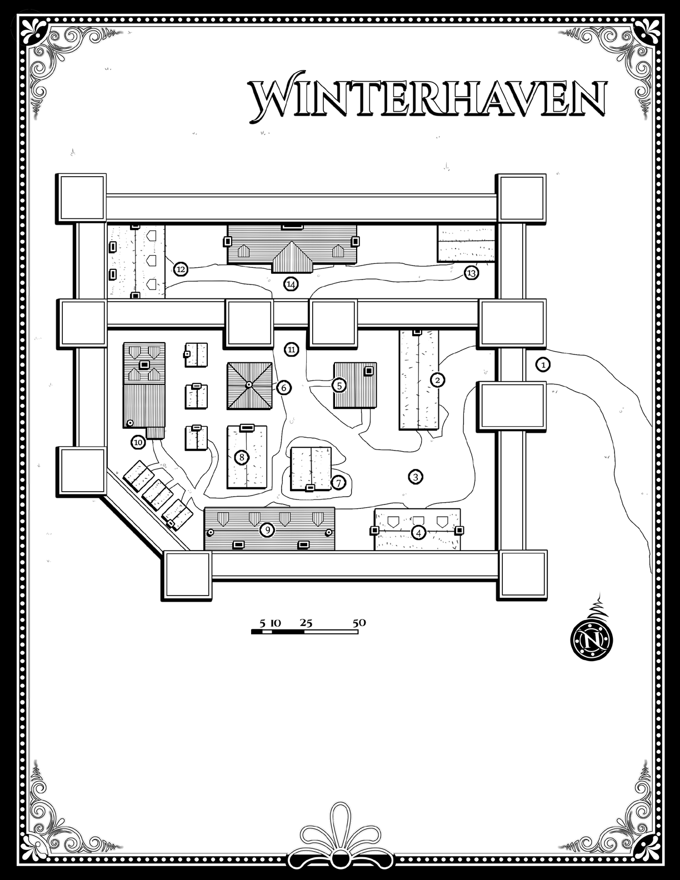

Winterhaven is a walled village in the heartlands of [Cormyr](http://dustin.wikidot.com/cormyr).

The population of Winterhaven is predominantly human, with a scattering of dwarf families, and a handful of individuals of other common races, including a couple of elves. Most residents of Winterhaven have never traveled beyond the village vale. The majority of villagers are farmers, though the walled heart of Winterhaven employs various craftspeople as well. Wagons occasionally head east down old King's Road from Winterhaven to find trade with the next village, which lies five days away.

Ernest Padraig, the Lord of Winterhaven, is descended from the noble family that ruled the area under edict of the old king. Folks around Winterhaven were happy with Lord Padraig's father's authority, and they have found answering to the rules of the new lord no more arduous. On the other hand, Padraig doesn't have absolute power. Winterhaven is primarily an agricultural village based on barter and trade, though Lord Padraig keeps a monetary system afloat with his own coin.

Город сильно расстраивается. Возле города построена огороженная стоянка для караванов.

В городе возможно находится кто-то из "Братства"

## Temples

### Temple of Chauntea

The only temple in Winterhaven is this small temple to Chauntea, built of interlocking stones carved in a pattern of stripes and spirals.

## Locations of Note

### Valthrun’s Tower

Originally built as a watchtower for Keegan’s Keep, this five story structure is the tallest building in Winterhaven. Valthrun is a sage and scholar who primarily occupies the top two levels of the tower.

Wrafton’s Inn. The only inn in the area, Wrafton’s is spacious and comfortable, with a large public room and alehouse which offers beer, wine, and, on occasion, spirits. Meals consist of simple fare cooked well and properly seasoned, and the portions are generous. The spacious hall fills each evening with the residents of Winterhaven, farmers from the surrounding hillsides, and any hunters, trappers, or

adventurers who happen to be passing through.

## Important Characters

### ~~Lord Padraig~~

~~Personality: lazy, dull, spoiled~~

~~The local lord of Winterhaven is a man with little imagination and almost no initiative. He is content to simply collect his taxes and do little more. Despite this, he has managed to maintain his position largely due to the remoteness and relative unimportance of Winterhaven.~~

### Sister Linora

Personality: humble, alert, confident

Sister Linora manages the town’s temple along with her acolyte, Gevarn. She is humble, quiet, and soft spoken, but is constantly on the lookout for any signs of the return of the Sharran cult.

### Thair Coalstriker

Personality: gruff, short tempered, professional

Thair is the town’s dwarven blacksmith and also took over the sundries shop shortly after the retirement of its previous owner. He is quick to anger and has a long memory for those who have wronged him, but cuts a fair deal and doesn’t believe in taking advantage of those who are in need. Being the patriarch of the only dwarven family in Winterhaven, hair is always happy to meet another dwarf, particularly young dwarven men who might be suitable matches for his young adult daughters (both of whom are accomplished blacksmiths in their own right and neither of whom have the east bit of interest in being married off to some scruffy adventurers).

## Other Notable Characters

A gen

WinterhavenLocations

Key Locations

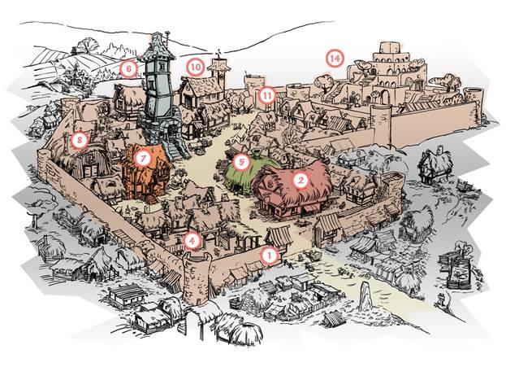

The map above depicts all the numbered locations discussed in this section.

### 1. Outer Gate and Walls

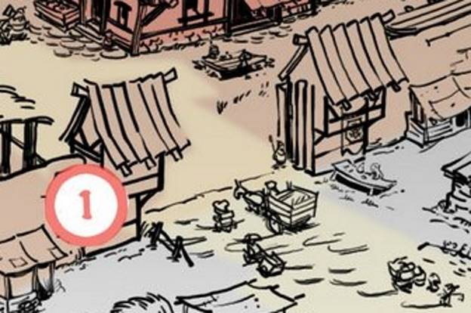

Open by day, closed and barred at night, the outer gate is policed by two guards regardless of the hour. They nod amiably to locals, and point travelers (whom they assume to be traders) to Wrafton’s Inn.

Winterhaven’s walls have a narrow parapet extending around the inside edge. If Winterhaven comes under attack, the Regulars and what militia can be raised from among the civilians guard the walls to stave off the threat.

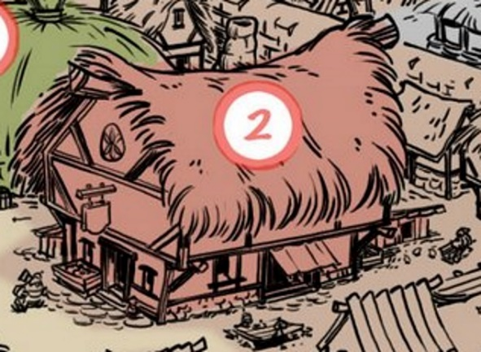

### 2. Wrafton’s Inn

This spacious inn and tavern serves as the public house for the region. Like alehouses everywhere, Wrafton’s Inn offers beer, wine, and, on occasion, spirits. Meals are served for those with the coin, and beds for travelers are available. A crowd of townsfolk gathers each night to drink, gossip, sing, and play games of chance.

In addition to the locals, any travelers passing through Winterhaven are found here.

Anyone in Wrafton’s knows the general history of the town and the nearby ruined keep.

### Salvana Wrafton

Wrafton’s owner and proprietor is a female human named Salvana Wrafton. She employs several waiters, waitresses, and cooks. Salvana is friendly and open, quick with a smile and a warm welcome.

### Eilian the Old

This old farmer is a regular customer at Wrafton’s. Every night, Eilian takes a seat at a table in the corner. He has a farm down in the valley along the Old King’s Road. Eilian has an interest in Winterhaven’s history. He is a good source for local information, and he loves to talk.

### 3. Market Square

Every other day or so, carts and wagons gather in the square and offer goods to the people of Winterhaven. Once each week, the official Market Day acts as a siren’s song, calling most of the townsfolk to shop and socialize in the square. Farmers sell produce, hunters hawk smoked meats, townsfolk sell crafts, and sometimes a trader from the east sells implements or costly goods.

On any given day, there is a 50% chance that items from the adventuring gear list in the Player’s Handbook are available for sale here. Adventurers will almost never find armor, weapons, implements, or magic items in the market square, however.

### Telshara Shardren

Telshara turned away from the forest of her elven roots to live an urban existence, if Winterhaven can truly be called such. Telshara can be found in the square on Market Day selling wildflowers from her cart. She is happy to tell visitors about Winterhaven. She collects wildflowers north of the town.

Half-elven herbalist

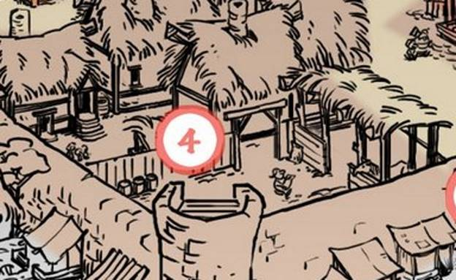

### 4. Stables

On market days these stables are filled with mounts and other beasts of burden used by sellers to haul wares. Travelers can stable their mounts here for 2 sp per day. Rarely (10% chance), the stable master has a riding horse or wagon for sale, as listed in the Player’s Handbook.

### **Seszgar Merritree**

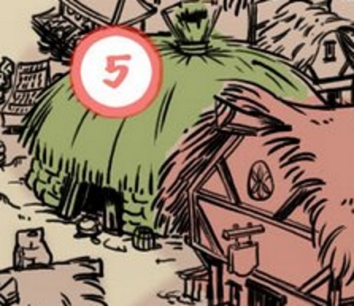

### 5. Smithy

A dwarf named **Thair Coalstriker** owns the town smithy. PCs can purchase a variety of mundane wares here, including spikes, weapons, heavy armor, and so on. Simple weapons are readily available, but military weapons require one day to complete, and superior weapons require a week of work.

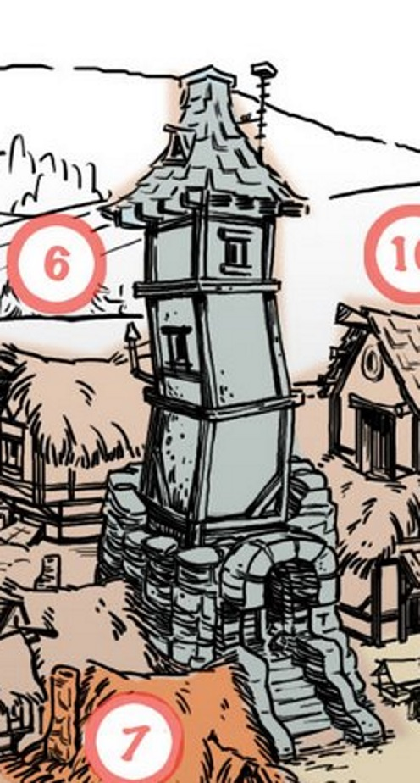

### 6. Valthrun’s Tower

This five-story structure is the highest building in Winterhaven. The tower is rumored to be over 300 years old, and Valthrun the Prescient is its most recent resident.

Valthrun doesn’t use much of the tower; he inhabits the top two levels. The bottom three levels are locked and empty except for the stairway connecting them to Valthrun’s quarters. The sage and scholar has a small selection of 1st and 2nd level rituals that he is willing to sell once he determines the worth and merit of an adventurer. Refer to the Player’s Handbook for a list of rituals.

**:** Valthrun is a sage and scholar who lives in a tower within Winterhaven’s walls. On occasion he shows up in Wrafton’s to socialize. Valthrun is knowledgeable about the area. Valthrun is a good listener, asking just enough questions to keep whomever he speaks with talking.

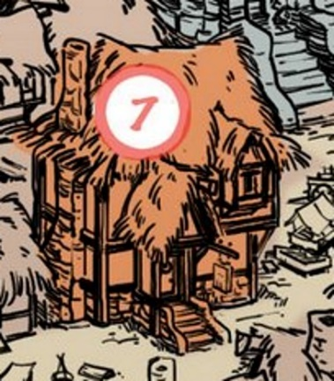

### 7. Ontar’s Goods

**Bairwin Wildarson** traveled the world, or so he claims, before setting up shop in Winterhaven ten years ago. He has a variety of items available for sale, including anything off the list of adventuring gear shown in the Player’s Handbook. He occasionally has a few 1st-level magic items for sale, and he sometimes has a couple of potions of healing available in the shop.

Baiurwin Wildarson was cultist of Shar and was killed by party of adventurers. Ontar Vorauth then reopened store in Winterhaven

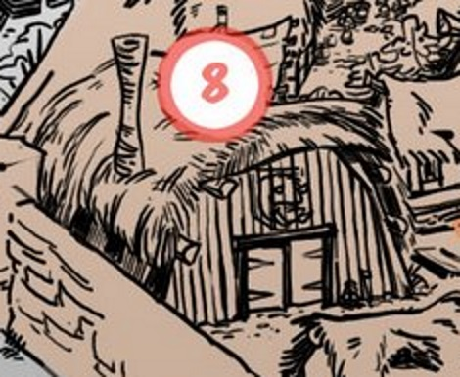

### 8. Warrior Guild

Winterhaven townsfolk can join the Warrior Guild and train, once per week, in basic sword and shield skills. The guild trains in Market Square on days when the market is not open. Some citizens earn militia pay (a few silver pieces per year) by training at least once per month and being on call for emergencies.

Maerclorn Rowanmantle, swordcaptain of the Winterhaven Regulars of Purple Dragons Contingent, also oversees the Warrior Guild. He can be found here, in the barracks, or on guard duty, depending on the time of day.

### 9. Tenements

The various structures house the town residents who don’t own farms or who work in the businesses within the walls. Most of the folk who live outside the walls are farmers and crafters who bring their wares to the Market Square to sell or trade.

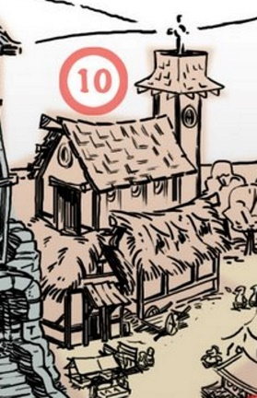

### 10. Temple

This large stone structure is the town’s temple. Eldath

The temple priest, Sister Linora, runs services in the temple three times per week, but otherwise she is not often present. She prefers to travel among the homes outside the walls, dispensing care to villagers and animals and helping with various farm projects. Although Linora is not a cleric, she does know the following rituals: gentle repose, cure disease, and raise dead.

Graveyard: Winterhaven has a graveyard for which Sister Linora serves as caretaker. The graveyard is located a short distance south of the walled town.

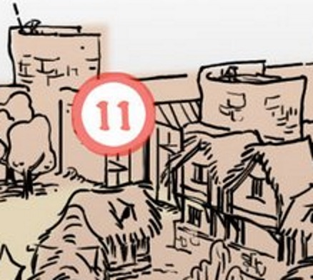

### 11. Inner Gate

This gate is closed and guarded by two Winterhaven guards during the daytime. They sternly regard anyone who approaches and question all who wish to visit Lord Padraig in his manor without an appointment; however, PCs who exude an air of mystery and importance might convince the guards to let them pass if they act amiably.

* Shuldroon Vrabant
* Wendur Rhauntagar
* Rory Hawkmantle
* Talonar Ghalhunt
* Scamar Glavreth
* Berent Whitewave
* Landryn Nurennanthur
* Jeth [and its local variant “Juth”] Askalan
* Ellard Roril
* Brace Rhauntagar
* Wend. Downdagger
* Beltar Gauntur
* Welwyn Manycoats
* Tal Narbrace
* Scamar Downtlurk
* Noke Dunstrand
* Brorn Heldeth
* Maerand Ardruth
* Taran Applecrown
* Belgor Halorth
* Rorn Ironstone
* Maerand Hawkmantle

### 12. Winterhaven Siege Supplies

Though it hasn’t happened in a couple of years, on occasion Winterhaven comes under attack from bands of goblins, kobolds, or even gnolls. When such an event happens, the townsfolk seek refuge inside the Lord Padraig’s walled keep and subsist on the supplies of water, flour, and other basic foodstuffs stored here.

The contents of the storehouse are protected by thick wooden walls and a sturdy locks.

Note areas 12, 13 & 14 are all shown together below.

### 13. Winterhaven Barracks

This military-style barracks is home to Winterhaven’s forty professional guards, the Regulars. During the day, only half can be found here; the others are on patrol. At night, thirty guards sleep here while ten are on duty. The guards in the barracks respond quickly to any call to arms from the manor or elsewhere within the walls of Winterhaven.

Note areas 12, 13 & 14 are all shown together below.

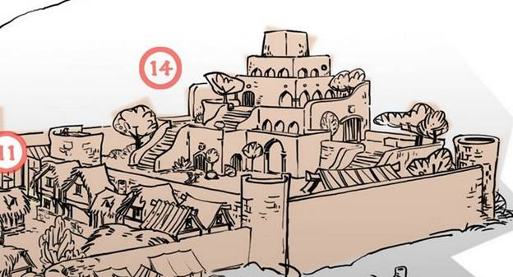

### 14. Manor House

This grand manor home was built when Winterhaven was an outpost of the Nerath Empire. Staffed by five servants, the manor house where Lord Padraig, his wife, and their four sons live is a beautiful example of stone architecture in a town otherwise composed of thatch and wood.

Lord Padraig is willing to meet with adventurers who visit Winterhaven if they specifically seek him out. He also frequents Wrafton’s Inn.

Lord Padraig: From time to time, the town’s lord visits Wrafton’s. All those present doff their hats and call him Lord, after which he retreats to a corner table and sips beer. He is amenable to speaking with adventurers who approach him. He initially assumes they are dignitaries or possibly merchants scouting new trade routes. Regardless, if he believes they are merely treasure hunters, his respect diminishes unless they prove their worth.

Sources:

[*http://dustin.wikidot.com/winterhaven*](http://dustin.wikidot.com/winterhaven)

## Purple Dragons & War Wizards

### War Wizards

War Wizards operating in the area come to Thunderstone only to investigate suspicious matters reported in Thunderstone itself.

Otherwise, they work up and down the Cormyr side of the mountains to the east, and probe into the Hullack from the north, avoiding Thunderstone except to occasionally “lie in wait” for brigands, smugglers, Zhent agents, or monsters flushed out of the forest, whom they believe will cross the Stag’s Skull Bridge in departing the Hullack on its southern edge.

The only seldom-used spell popular among War Wizards operating against foes in the Hullack is the “loft” spell, which is a swift, long-range cone area of effect spell that levitates warm-blooded, living mammals of the same size as the caster or larger precipitously twelve feet straight up into the air, and then (caster’s choice, made during incantation) ends abruptly, dumping them back down again in a fall, or ends in a feather fall (possibly leaving them a visible target for longer). The fall and crashing up into branches might cause minor damage (1-2 hp), but the main purpose of the spell is to “flush out” persons in hiding, so archers and other Purple Dragons can act against them (a lofted target can’t run away until they are back on the ground, though they CAN grab hold of tree boughs and get up into a tree). The spell is sometimes used on “friendlies,” to boost them up into a tree beyond their reach, or to extricate them from thorns or a bog.

### Purple Dragons

The local Purple Dragons have a handful of trained scouts and rangers in the ranks, but they are primarily used to track horse-thieves and smugglers, and to watch suspicious movements in the foothills of the mountains, not to make forays into the Hullack (though moots “just inside” the forest, or frequent forays into the Hullack, will be investigated). This is because, yes, they tend to work to keep critters north of the Thunderflow rather than patrolling the Hullack in any strength (forays into the Hullack are made by larger forces organized and brought in from Arabel and elsewhere for specific missions). Druids are almost unknown among the ranks of Dragons. Local lads and lasses enroll in the Dragons, some out of interest and some because they find it their best chances of good employment, but they tend to find themselves swiftly reassigned to elsewhere in the realm, with only a few veteran Dragons stationed locally as “local experts.” This policy is to keep corruption among the Dragons to a minimum (young recruits may come in with hidden obligations or debts, or be too eager to make “big coin” quickly, and so be susceptible to bribery and just “looking the other way” when faced with malfeasances by longtime friends or family).

## Дворянские семейства:

### Hawklin

In Thunderstone proper, the Hawklin family owns a row of stores along “the Rise,” the main street (that parallels the Thunder River), and two homes: a modest dwelling with stables in its own small walled orchard and garden, hight “Thundershaws” and used for putting up guests, business clients, and sometimes by certain Hawklins who want to entertain away from the rest of their kin; and Hawklinforce, a stone mansion with its own high stone walls, stables, wagon sheds, and brewhouse. From “the Force,” local factors (trade agents) of the Hawklins administer the dozen ranches and crop farms (cabbages, barley, oats, and parsnips) owned by the family, and rent out family coaches and wagons to locals for divers purposes. As a result, the Hawklins are prominent locally, their views respected and heeded.

### Huntsilvers

The Huntsilvers maintain a lower local profile. Their tall-towered stone mansion is known as Hunting Castle, and has an impressive stone wall and stout front gates, but isn’t otherwise fortified. It is perhaps the most defensible large building in Thunderstone, but its small enclosed grounds are crowded with large, old trees (oaks and duskwoods), the boughs of some of which offer easy access to some of the lower Castle windows. There are persistent local rumors of secret tunnels connecting the cellars of Hunting Castle (which are said to contain all manner of gruesome sacrificial cult altars or Loviatar-loving flogging and trysting “dungeons”) with secret passages in the walls of scores of local buildings. According to Elminster, there are two secret passages, meant to allow olden-day Huntsilvers to arrive and depart without being seen by kin or slayers hired by rival noble families, they are guarded by helmed horrors, and there are no altars or pleasure-dens.

In Thunderstone, the Huntsilvers generally keep to themselves, moving about the village in closed coaches or on fast horses. They use Hunting Castle very much as a retreat, in which to read and catch up on hobbies (such as, for several Huntsilver ladies, crafting gowns and practicing at the lute, handharp, and with voice, and reportedly for some Huntsilver males, wenching with “laugh-pretties” brought up from Suzail for such purposes). The family owns about thirty farms, all worked by tenants, well to the south and southwest of Thunderstone.

Hunting Castle and Hawklinforce both back onto the Thunderflow, having their own (modest and largely disused) docks and boathouses, and face onto the “best” street in Thunderstone, the winding Nightcloak Ride, which is lined with most of the better old stone dwellings in the village. It lies largely north and west of the Rise, but hooks sharply south just west of Stag Skull’s Bridge, to intersect with, and end at, the Rise.

### Illances

### Naerinths

### Summerstars

### Wyvernspurs

The Illances, Naerinths, Summerstars, and Wyvernspurs all own modest walled stone homes in Thunderstone, but visit them seldom (in the general way of nobility, such “nighthearth” houses are used as overnight way-stops when travelling, to host occasional meetings with business associates, and as retreats or trysting sites by individual family members. These four families are locally most active elsewhere (the Summerstars in Firefall Vale, which I shared lore about back in the 2004 replies here at the Keep, I believe [Sage or Wooly or Kuje, please jump in and correct my dating if I’m misremembering], and the other three noble houses largely to the north of the Hullack, or at least of the Thunderflow.

### Immerdusk

The Immerdusk noble family owns four old but solidly-built homes in Thunderstone, and owns six farms just south of the village proper. All are worked or inhabited by tenants, and Immerdusks are so seldom seen in this region that many locals believe them to be extinct, and that the factors speaking for them are actually courtiers working for the Crown, who just won’t admit that they’ve taken over the chattels and holdings of the Immerdusks.

### Indesm

House Indesm owns a shop on the Rise and maintains very modest lodgings (a suite of four rooms, occupying an entire floor) above it, with the shopkeeper and his family dwelling in the gabled and dormered attic above them. However, they are seen in Thunderstone seldom, and come and go without fanfare or much in the way of coaches, outriders, servants, and the like. The Indesms own sixteen ranches and farms, mainly east of Thunderstone. All are worked by tenants, though the Indesms visit and inspect them often. This family keeps mainly to the hold of Hawkhar (sometimes called Hawkhar Keep or more often and formally “Hawkhar Hall,” though most folk these days now call it simply “Hawkhar”), consisting of a fortified stone mansion and tower at the heart of a walled horse-farm where many fine mounts are bred, reared, and trained. The walls also enclose a small woodlot and orchard, and have an outer “thrust” or loop of wall, pierced by two always-open gates, that cradles the hamlet of Hawkhar, a small settlement dominated by the families of Indesm servants.

The Indesms are typical of most Cormyrean nobility in the countryside; they have and dominate their own settlement or hold, and only visit and rent or own dwellings in the villages, towns, and cities of the realm. The other three Thunderstone-home-owning noble families follow this pattern, too; they are the Houses of Buckfast, Haelbroke, and Yellander.

### Yellanders

For more about the Yellanders, interested readers are directed to SWORDS OF DRAGONFIRE. This House did not end with the execution of the lord who featured therein, because King Azoun would not hear of the three estranged and blameless-of-treason Yellander nieces who dwelt in Suzail being shamed and paupered by the actions of Lord Prester Yellander. The War Wizards had already thoroughly upset the three with sudden, brusque mind-reamings (which confirmed their utter innocence; they were wholly unaware of Lord Prester’s drug-smugglings, or his assembling of a private army and the murders he directed them to do). One of the three nieces, Anathae, was a longtime friend and confidant of Queen Filfaeril, who took charge of the rather dazed Anathae and briskly steered her into marriage to a commoner she’d long had eyes on, a Palace courtier by the name of Hresker Falbruin. So there’s now a capable and tactful Lord Hresker Falbruin, charged by Queen Fee with finding suitable and happy mates for Anathae’s two sisters, Paerile and Tannaura (a process that is taking years because both of them are rather shy, delicate ladies and Hresker, Anathae, and Filfaeril are all agreed that the very last thing that should happen is settling them with less than ideal partners).

Hresker and Anathae Yellander now dwell in Whitewings (the renamed Yellander seat in Galdyn's Gorge, a modest, unwalled keep-and-attached stone mansion surrounded by gardens and a deep, wooden-spike-filled ditch to discourage marauding wilderland monsters; its new name comes from all the doves raised for food by Anathae’s longtime maids, who came from farming families known for their flavourful dove pies), visiting Suzail only for major Councils and at the end of summer. Prester Yellander’s simple, rustic hunting lodge on the edge of the Hullack Forest sits disused, and will soon fall into ruin if not maintained.

### Buckfast

Less well known in Suzail are the poorer, more rustic local noble families of Buckfast and Haelbroke. These “true bloods of the Thunderflow” lead lusty lives of running their farms directly, brewing and distilling, imbibing the results, and hunting from the saddle.

They also seem to have “ridden” great numbers of willing local lasses, and are impoverished in part because of all the bastard offspring they help to support - - which has linked them, time and again, to divers local families, businesses, and farms.

Their byblows have been sent literally by the score into the ranks of local Purple Dragons, who are inclined to look the other way at Buckfast and Halebroke indiscretions, which in turn has encouraged male members of these houses to becoming accomplished rakes, drunkards, and local “rowdies” behind many a local brawl, wildly whooping midnight gallop, accidental fire, and prank.

The current patriarch of the Buckfasts is Lord Rothtil Buckfast, whose hardy, lusty, fun-loving mate is Lady Suvreene Buckfast, and they dwell with three sons (including the family heir, Ravance) and five daughters at the family seat of Buckhaven Hall, a walled manor house and ‘home farm’ in the countryside east of Thunderstone. This “heart of the Buckfasts” household also rents rent two rooms above a chandler’s (“Maerikho Hayhondlow, Chandler to High and Low”) on the south front of the Rise.

Other prominent Buckfasts include Melhard, a fat and blustering old bellower of a rake with a legendary capacity for drink, and Sargram, an aging but still deadly fighter-of-duels and bedder of anyone female and handy (the reason for a lot of those duels; noble wives are his favourite quarry, and his outrageously leering flirtatiousness [or “charm” as the ladies tend to prefer to call it] seems to conquer many of them).

### Haelbrokes

The current head of House Haelbroke is Lord Larandyr Haelbroke, a haughty, humourless retired soldier (he recently departed the rank of ornrion, a West Reach posting, in the Purple Dragons when his father Lord Uskarr Haelbroke died, his mother Dardorra having predeceased Uskarr). Larandyr’s stunningly beautiful wife is Lady Mirljarla Haelbroke (formerly a Truesilver), and they dwell with their two daughters, Tasharra (the family heir) and Raedaera at the family seat of Buckhaven Hall, a rather spartan walled keep and ‘home farm’ in the countryside west of Thunderstone. They also rent a luxurious house on Nightcloak Ride in Thunderstone (Nightowl Roost, which is owned by Storm Silverhand but managed for her by the suave estate manager Maland Orlstand of Suzail, a secret Harper) where Lady Mirljarla spends increasing amounts of time entertaining noble lady friends “come out from Suzail to see the rustics.” A glowering Lord Larandyr rarely attends these visits, and the couple’s two daughters are caught in a tussle between their parents for their time and attention (although Tasharra and Raedaera, who have both inherited their mother’s raven-black hair and smoky-eyed good looks and buxom curves, dearly want to see the latest “cityside” fashions and manners, they both LOVE riding, ruling, weapons-practice, and all the other “lordly” stuff their father wants to teach them and do with them, that are more often the province of male nobles when their female counterparts are confined to empty-headed chatter in parlors and “lace-chambers”).

Other prominent Haelbrokes include Galragar, Mresper, and Borlingar. Galragar, the eldest, is Larandyr’s uncle, and the other two are his cousins. Galragar is a fair-haired, unshaven, rollicking meaty bull of a man, load and coarse and jovial. Borlingar is a younger, dark-haired echo of Galragar, whereas Mresper is sly, witty, slender, and agile. All three are tirelessly-energetic roisterers, wenchers (Mresper may on occasion also prefer young and handsome male partners), and fun-seekers, the bright stars of every revel they take part in. They are always thinking up some new “society” or club or prank, some entertainment for themselves and those who “ride with them” to take part in; Larandyr’s last attempt to host a solemn feast for Suzailan lords he desired to impress was “pranced” (in the real world, we would say “crashed”) by Galragar and Borlingar leading a dozen strapping local lads, most of them wealthy or highborn or both, all riding horses and wearing heavy makeup and beautiful womens’ gowns, garters, and all, into the ballroom to a skidding dismount and wild dance with the attending - - and utterly astonished - - noble lords. This is a typical prank, neither a highlight or lowlight, but it strengthened Larandyr’s cold distaste towards all three of his “wild wolves” of kin, whom he disowns and shuns at every opportunity. (His house wizard, a lean and homely mage by the name of Baerglan Dunstag, who is of course a War Wizard, refuses to let Larandyr bar his gates to the three or move to try to legally dispossess them [an effort that would fail, anyway, as only the Crown can strip someone of their rightful heritage, and then only by exiling them and taking away their citizenship as well], but Larandyr refuses to recognize or speak to them, always addressing cutting remarks to any of the three to any handy servant or statue or potted plant, loudly enough for the shunned kin he wants to hear, to do so. For their parts, the three are amused at Larandyr’s attitude, not upset or ashamed.)

Those are the living nobles. There are indeed a handful of extinct ones that will serve for answering your second question. For now, enjoy (I hope) this lore.

Are there any "extinct" local noble families, who might have dabbled into necromancy and/or demon worship, and were either exiled or executed or imprisoned?”

Ed replies:

## Extinct Noble Houses

There are indeed.

Thunderlunnar (or more recently, “Thunderlans;” both terms mean inhabitants of Thunderstone) and other locals might believe the Immerdusks are extinct, but in truth the following noble families, once locally prominent, have vanished: the Houses of Bracebolt, Drauthglas, Mallowbridge, and Tulwood.

### Drauthglas

According to what local legends once heeds, any or all of these families may well have dabbled with necromantic magic and/or worshipped or consorted with demons, but there are no local tales or suspicions of the old, old Drauthglas clan being exiled, executed, or imprisoned. “Longest gone and least remembered” is how most locals recall them, if at all; an ancient name clinging to the Hullack forest, and no more. So consider them a possible but least likely candidate, of the four choices, and pass on to the others.

### Bracebolt

The House of Bracebolt flourished in the time of King Duar, and had a reputation for handsome good looks and skill-at-arms, not any interest in magic. Most Bracebolts died in battle (fighting for Cormyr, loyal to the king of the day), but two were imprisoned for short periods on suspicion of murder; one [Lord Helaerd Bracebolt] was acquitted and the other [Lord Rorell “Rory” Bracebolt] escaped from a dungeon, never to be seen again (he was pardoned in absentia when later War Wizard evidence pointed to another person as the murderer, and was widely thought to have lived out his days either “living wild” in the Thunder Peaks or living simply as a forester under another names, somewhere in Battledale or Featherdale).

The family line went extinct in 1225 DR, when the childless, unmarried Lord Belarkus Bracebolt died fighting for the Crown in one of the many, many battle-victories of King Dhalmass.

### Mallowbridge

The Mallowbridges are quite another matter. The males of this family tend to be soft-spoken, smiling men of dark hair, good looks, and cruel lack of morals, who swindle and deceive and cheat their ways through life, employing secretly-hired agents to end unpleasant problems (such as rivals or those they owe coin to) with a sharp dagger some night.

The last Mallowbridge is thought to have died a pauper’s death in the reign of Rhigaerd II, but the family (which rose to nobility in the reign of Andilber, through wealth and battle prowess and informing the Unfortunate King of several plots against him) lost its title and standing (though not properties) by the decree of King Palaghard II, earning this unusual fate because they were suspected of scores of bad deeds, but no hard evidence could be found against them. They had access to dark magic and used it, because every last War Wizard sent to investigate them died, mysteriously torn apart by unseen creatures who left no traces - - creatures who devoured or carried off the heads of the unfortunate mages, and cast many dark and powerful spells on the remains and the death-sites, that prevented other War Wizards from using spells to determine just how they died or what they saw or learned.

So this family are prime candidates for what you have in mind. The patriarch of the House when they gained noble status was Hander Tarius Mallowbridge, created Lord Tarius Mallowbridge (he never used his childhood name “Hander,” which he hated, once his father was dead; Tarius was the name of his grandsire, and his father had been Honder Mallowbridge, leaving the son heartily sick of being called “Hander son of Honder”).

Lord Baeryn Mallowbridge was head of the house when it was stripped of nobility; he was exiled, but his sons Tonthur and Naernyn were not. Both went on to have large families, that finally dwindled down to Esker Mallowbridge (a descendant of Tonthur), who died living alone as a forester in the Hullack, sometime in either the winter of 1331 DR or the spring of 1332 DR.

However, there are many local tales (mostly dark tales of malicious spellcastings) of various Lady Mallowbridges dabbling in magic, sometimes magically ruining young local men after seducing them. Although Mallowbridge wives came from many families (often of wealthy non-noble Marsemban stock), the tales generally portray them as slender, beautiful, and as having long, long dark hair. Elminster attests that many of the never-wed Mallowbridge daughters, who dwelt in various family homes and became aging aunts and then very-long-lived crones, were accomplished sorceresses or trained wizards, and aided and taught each other, waylaying and seizing the scrolls and tomes of traveling mages when they could to increase the “family power.”

The wife of Tarius was Lady Tamglaera, the wife of Baeryn was Lady Anglorae, and the wife of Glarem (the wealthiest and most powerful Lord Mallowbridge between Tarius and Baeryn) was Lady Resildra.

Tonthur’s wife was named Harellae, and she is known to have been powerful in magic, ruthless, fearless, and to have often fared far in the Hullack, walking alone and using spells to slay creatures that she then devoured raw (earning her the nickname “Wildfangs”).

Naeryn’s wife was Oloebrae, a delicate beauty who was masterful in acting and manipulation, and who probably poisoned Naeryn when she tired of him (she went on to take two subsequent husbands, both wealthy merchants of Suzail, and the first of them also died of poison, as did Olobrae’s sons Ithril and Ongammur. Only a daughter, Taeril, outlived her mother, and she did so by fleeing to Waterdeep and disappearing (probably altering her face, taking another name, and plunging into a new life as a drudge-servant or tavern dancer, though one tale whispers that she used spells to appear to be a man, and rose to become a guildmaster; this tale may well be true, or may have arisen because “Taeril” is a name borne by both males and females in Cormyr).

### Tulwood

The last candidate family is the House of Tulwood, a line of arrogant, fair-haired, malicious men (and a succession of commoners who married them, because they seemed uniformly unable to attract brides from amongst the nobility of the realm) who were known for skilled swordsmanship, feuding, and personal obsessions. Some were obsessed with worshipping the Cormyrean monarch of the day, some were obsessed with married noblewomen or priestesses they could not have, and some were obsessed with collecting oddities or with mastering strange hobbies (such as tying miniature animals from knotted string, or painting miniature likenesses of lovers on the fingernails and toenails of their wives).

Aside from fighting, riding, wenching, and feuding, however, few of the Lords Tulwood accomplished much, though Lord Baerent Tulwood was that rarest of things: the head of a noble house (during most of the reign of Azoun I) who was also a master swordsmith.

The Tulwoods rose to nobility in the reign of Irbruin, ennobled for military service to the Crown (defending easternmost Cormyr against brigands, monsters, and various self-proclaimed kings of their own fledgling realms). From the first Lord Tulwood, Omburr, the family had many sons and few daughters, tended to embrace military careers, and tended to have short and violent lives. The last of the many Lord Tulwoods was Korlandur, who died in the summer of 1319 DR in a violent fall over a cliff on horseback that shattered most bones of both horse and rider (the plunge may or may not have been due to foul play; Korlandur was a cruel man known for unhesitatingly disfiguring the faces of those he disagreed with by means of his metal-barbed horsewhip, who’d earned himself many foes).

The Tulwoods were bullies who tended to hire mercenaries and wizards to beat any foe who stood up to them (though they were careful never to cross any courtier, local lord or Crown agent, the Obarskyrs, or any of the three “royal” noble families), and many of them dabbled in magic as a hobby (usually without much results, but then, those who succeed in dark summonings and the like seldom want to advertise their successes in a realm so dominated by War Wizards).

One Tulwood, a heir Rantaver (his younger brother Borovan became Lord after the death of their father, Gulthur), was exiled in the reign of Duar (for strongly suspected but not-quite-proven treason), and more than a dozen Tulwoods were imprisoned for short periods, for various violent actions perpetrated against other nobles (or in one case, a visiting envoy from Amn). There are no records of executions, but there are strong suspicions of Tulwoods being involved in dark magic and of summoning demons, so they, too, are candidates.

Perhaps you could use both the Mallowbridge AND Tulwood families, with Bracebolt as a red herring, and REALLY get your players deep into intrigues and shadowy conspiracies and shadows from the past. Heh-heh, and so forth.

So saith Ed, opening up several cans of worms with great glee, it seems to me.

Ah, Cormyr, so dear to my heart and so delightful. May your tale be told, some day and some way.

love to all,

THO

Джерело: <

**Ed on Harper and Zhent agents in Thunderstone, as well as a herald writing his way into the headlines......**



Cheers

Damian

There is a local herald, Bannermere, but this is a new office held by a novice, a young, slender, brown-haired man originally from Berdusk, who is polite and rather shy, and derives most of his income by designing and limning signs and writing letters for locals (he is not a Crown herald). He keeps to Thunderstone, and interested clients come to see him; it’s recently come to light (much to his embarrassment) that he secretly writes salacious chapbooks for sale in Scornubel and Waterdeep, including the popular “Rorel the Conquering Blade” series (in which the debonair, swirling-cloaked Rorel beds an endless series of willing women, often after dueling their craven and cruel wife-beating husbands). Interestingly, there’s long been a rumour that the Rorel books were penned by the same anonymous hand that once presented the now-banned chapbook “Filfaeril Bound And Willing” to a receptive Suzail and even more eager Purple Dragon posts up and down the Realm, but a blushing and stammering Bannermere denies ever even dreaming of portraying the Dragon Queen in such a light. (Another rumour whispers that Filfaeril, who has been officially silent on the work, secretly enjoyed it very much and cajoled her royal husband into acting out the events of several of the encounters therein - - but rumour, like a barking dog, oft makes much more noise and arouses more ire than it in truth should.)

So saith Ed, who seems to be really building up lore so Asgetrion, Damian, and anyone else who wants to can use this area for a campaign setting. Whee!

(I know Ed expects to have an answer for Asgetrion's fourth question next, then Damian's most recent query. Glancing over Ed's reply, I want to emphasize that the Zhent agents he mentions are NOT the only ones, just the only long-term-resident ones; to avoid being easily exposed, the "do the dirty stuff" Zhent agents, of whom there are probably around six to eight at any one time in the Thunderstone area, "move through" the district and on to elsewhere, being replaced by "the next wave.")

love to all,

## Important Organisations

### The Harpers

The Harpers have two Harper Agents operating within Thunderstone and maintaining Safeholds for more active Harper Agents within the area. Thunderstone is seen as a good training ground for Harper novices, as it is a route travelled by a known Zhentarim Agent and is home to a known Zhent Paymaster and Spy

The Harpers have two safe-houses and lore-moots in Thunderstone, both the homes of retired, aging, limping from old wounds ex-Dragons (who are now covert Harper agents). They do nothing at all to attract attention to themselves, beyond opening their doors after dark when certain signals are given, and taking in guests they hide in their cellars, in secret passages, and in hidden attic areas. An ever-changing succession of younger and more active Harper agents move through the area and do all the fighting, skulking, prowling, and spying (the Harpers in Berdusk regard the Thunderstone area as a good “training-ground,” but also send more experienced Harpers to watch over the novices, both to rescue them if need be and evaluate them).

The two elderly Harpers are the grizzled and laconic (most known for his severe limp and his jutting, oversized, sharp-pointed lower jaw) Pharvukh Bonehondur, once an ornrion in the Dragons who came from Teziir and joined the Dragons as a youth, in a hiring fair in Suzail; and Malaeva Irlingbreak, a sharp-tongued, tall but stooped by her aches, slightly-limping and cane-using woman who has long, untidy white hair, piercing black eyes, and a habit of purring audibly when contented or amused; she was once a constal in the Dragons, at High Horn, and earlier in her career, when holding much lower ranks, served for many years in Arabel.

Both of them are expert at tending wounds and keeping their mouths shut; Bonehondur runs a knife-and-tool sharpening service out of his home, and Malaeva makes carved and ornamented wooden front doors and shutters (and a few small carry-coffers, too).

### The Heralds

The Heralds have a minor presence in Thunderstone in the form of a novice Herald with the title of Bannermere. Bannermere is responsible for maintaining the geneology and heraldry of nobles in Thunderstone and settlements surrounding the Hullack Forest.

### The Zhentarim

The Zhentarim have two spies in Thunderstone. The first spy is an unwitting dupe named Tunstal Draeger, a shopkeep who provides information and delivers packages on behalf of his Zhentarim master Drustigo Parltath (a travelling merchant from Selgaunt). Tunstal is a false and expendable spy that the Zhentarim know is under surveillance by the Crown, Drustigo (whose cover is also blown) maintains the pretence of visiting this contact in order to take the heat away from the true Zhentarim spy Naerilda Jackalane. There are on average, 6 to 8 Zhentarim Agent operating in and around the Thunderstone region, they are rotated regularly to reduce suspicion.

There are no publicly-known Zhentarim agents in the area, but “everyone knows” they do pay locals for spying and passing on information, and that there IS a Zhent paymaster somewhere in Thunderstone. It’s almost certainly a shopkeeper, and the local Purple Dragons do keep close watch over one Tunstal Draeger, a seller (but not maker; his wares come from the docks of Marsember) of rope, cord, and wire.

However, the Dragons and even Draeger are unaware that Draeger is a decoy Zhent spy and paymaster, who continues to operate and be paid by a travelling Zhent master (a Selgauntan “manywares” caravan merchant by the name of Drustigo Parltath) despite the fact that the authorities are “on to him,” and the Zhents know this. While the attention is on Draeger, the REAL local Zhent spy, the scent and potion maker and seller Naerilda Jackalane, does the real spying. She’s a bone-thin, long-nosed, rather homely woman who’s a superb mimic and actor - - and VERY careful not to attract attention to herself. She openly makes regular herb-gathering and buying trips (gathering on the banks of the Thunderflow and in the verges of the Hullack Forest, and buying from specific farms), tries to carry on romances with several local Purple Dragons (purportedly because she’s lonely and desperate for a mate and has a “thing” for “men in Crown uniform,” but actually to allay suspicion and to learn what she can of local Dragon gossip), and is known to discreetly visit local households after dark to deliver love-potions and herbal ointments that aid in “love’s arts” (lubricants and stiffeners, to put it less delicately). She has no public skill in healing, but is known to make and sell very effective ointments that effectively deaden all pain (and itching sensations) in a localized body area, and secretly possesses about a dozen magical healing potions for her own use and to aid wounded Zhents who might need them. Her Zhent name is “Thunderblade” or just “Blade,” but Zhents who think they might be overheard while speaking of her are supposed to refer to her instead as “Thunderflow” so that what they say will be mistaken either for the river, or as a SECOND agent.

## Current Clack In Thunderstone

T h u n d e r s t o n e

During the partys brief stay in Thunderstone, each PC

picks up 1d3 rumors from the list below (roll 1d20 for

each item).

1. There sure has been a lot of Sembians around here. (True)

If not their merchants, then their adventurers. Just

as long as they pay in good coin and cause no

trouble, theyre welcome . . . barely.

2. Over the last tenday, three young men have disappeared from town. Informed folk say they fled from their oaths to marry their betrothed. Of course, the women say differently, but thats expected, eh?

(True)

17. Heard of two Sembian companies adventurin

round these parts: the Wolfmasters and the Ruby

Blades. The first group I seen with me own eyes,

the second I just heard of. Nossir, I dont like ei-

ther one. (True)

18. The three young men whove vanished in the last

5. You must pay Faril Laheralson 500 gold in order to

get a friend buried in Kelemvors Gardens special

burial place of honor. But anyone buried there is

greatly favored in the afterlife. (False)

6. The Vast Swamp is not as nasty as it used to be.

All of those adventurers stomping around has re-

duced the monster population to a safer level.

(False)

7. My cousins brothers best friend knows of an ad-

venturer who swears that theres a huge red gem in

the Vast Swamp, worth a kings ransom! (True)

8. Thunderstone is so far removed from Suzail . . .

things are a bit wilder here, the Purple Dragons

not as disciplined. Still, as long as the town is still

loyal, the crown allows things to continue as they

do. (True)

9. Theres this woman who lives in a hut beside the

cemetery. I hear that shell keep company with a

man whose gold is good. (False)

10. Ever hear of the Wolfmasters? Sembian adventur-

ing band, but their paperwork is all in order. They

went out to the Vast Swamp six days ago, never re-

turned. They musta run afoul of ol Slageye. Ol

Slageye? Hee, hee. Biggest beholder youd ever

see! (Partly true: the Wolfmasters did go into the

swamp. However, there is no beholder called Ol

Slageye)

11 There be a group o centaurs and satyrs, along with

some of them comely woodswomen, running about

in the Hullack Forest. Word has it that they arent

so happy about the Crown encroachin on their

lands. (True, but their concern is only mild at worst)

12. Thunderstone is more than just a frontier town,

Yessir, its a regular hotbed o intrigue. Why,

theres all manner of spies: Zhentarim, Harpers,

Sembians, druids watching how the Hullack For-

est is being treated, oh, many many others. (False,

or at least a very big exaggeration)

13. The Thunder Stone is a local famous site. Kiss it

for good luck afore ye go traipsin off inta danger!

(True)

14. The Crowns presence in town is a jest, and a poor

one at that. The one clerk representing Azoun is

so delicate, a strong wind could knock him over.

(True)

15. The towns bein watched, and that be truth. Who

watches us? One word: paladins. (False)

16. Unless ye are a Purple Dragon, stay outta the

Dragons Den. (True)

tenday all did so around the graveyard. (False)

19. I hear that hobgoblins have been spotted migrat-

ing from the Thunder Peaks to the Hullack Forest.

Ought to make life interesting. (True)

20. At this very moment, the Knights of Myth Dran-

nor and Elminster the Sage are exploring Hullack

Forest! (False)

## Sources

[*http://forum.candlekeep.com/topic.asp?TOPIC_ID=11269&whichpage=2&SearchTerms=ARABEL*](http://forum.candlekeep.com/topic.asp?TOPIC_ID=11269&whichpage=2&SearchTerms=ARABEL)

http://forum.candlekeep.com/topic.asp?TOPIC_ID=9685&whichpage=7

Джерело: <[*http://forum.candlekeep.com/topic.asp?TOPIC_ID=9685&whichpage=7*](http://forum.candlekeep.com/topic.asp?TOPIC_ID=9685&whichpage=7)>

 Джерело: <[*http://forum.candlekeep.com/topic.asp?TOPIC_ID=9685&whichpage=7&SearchTerms=HIGHKNIGHTS*](http://forum.candlekeep.com/topic.asp?TOPIC_ID=9685&whichpage=7&SearchTerms=HIGHKNIGHTS)>

[*http://forum.candlekeep.com/topic.asp?TOPIC_ID=9685&whichpage=7*](http://forum.candlekeep.com/topic.asp?TOPIC_ID=9685&whichpage=7)>

Джерело: <[*http://forum.candlekeep.com/topic.asp?TOPIC_ID=9685&whichpage=7*](http://forum.candlekeep.com/topic.asp?TOPIC_ID=9685&whichpage=7)>

# Immerford

# Holborn

# Ard Marie

# Rivers

## Immerflow

# SARUUN KHEL

Saruun Khel is an ancient minotaur city within the peak known as Thunderspire Mountain sometimes referred to as "the Labyrinth”. One of the many chambers of Saruun Khel was recently used as a black market trading city known as Seven-Pillared Hall established by a group of Amnian wizards calling themselves the Mages of Saruun who were driven out of Proskur by the Purple Dragons. While Sembia, lies the town of Winterhaven. The small town is surrounded by a high wall to help fend off goblin and kobold attacks. It is otherwise a small town and quite unremarkable, except for its proxim¬ity to two local landmarks.

To the southwest of the town is the ancient burial site of a shadow dragon, while to the northeast lay the cursed ruins of Keegan's Keep. The town was infiltrated by Sharran cultists in 1479 DR, and while the leaders of the cult were killed by a group of ad¬venturers, rumors persist that not all of the cultists were eliminated. their plot to gain control of the trade route between Cormyr and the Dalelands has been foiled, the remaining chambers of Saruun Khel are largely unexplored and adventuring parties regularly set out from Winterhaven, undertaking the hard three day journey west to seek fortune within the twisting caverns of the Labyrinth.

# Sessrendale

“Sessrendale was colonized shortly after Archendale’s founding by a number of Archendalesmen who didn’t care to live under the Swords (the Lords of Archendale). That was hundreds of years ago, mind ye. Over time, Sessrendale flourished and made out quite well without Archendale’s overlordship. Both Archendale and Sessrendale were lands of miners and traders, seeking to attract the wealth of Cormyr and Sembia. Worse yet, they were kin from long ago, and I’ve found that people can hate their kin even more fiercely than orcs. About a century ago, matters came to a head. I suspect that perhaps a couple of patrols met and skirmished after some hot words. In no time at all, the Archendalesmen mustered their army and set out to end their rivals, once and for all. Some of the finest folk in the Dales, and three archmages, died in that war. It should never have been fought.. -Elminster, 1367 DR”

Sessrendale is also known as the Dead Dale. When Archendale’s forces triumphed, the Swords ordered the total destruction of the land. Every building was burned or cast down. Everything that could be carried off to Archenbridge was taken. Before they left, Archendale.s soldiers salted the earth to ensure no one would return to the lands of their ancient rival.

The area of old Sessrendale is a wild place now. The steep foothills are littered with the wreckage of old mines, smelteries, and smithies. The gentle glens and fields are barren, still poisoned by the salt. Dark, wild forests that have not been hunted or logged for a hundred years encroach on the old fields of the Sessrendalesmen. No one but a few lonely trappers and woodsmen live anywhere near Sessrendale now.

Many areas of the Dale are plagued by the restless dead.

# Sessrenglade

The chief town of old Sessrendale was Sessrenglade, a small but prosperous village near the Thunder Gap road. The Archendalesmen attacked the town first, hoping to smash all resistance with one swift blow, but the village was defended by the Sessren mages  five powerful wizards who resided there: The mages proved to be the key to Sessrenglades defense, and the town was not taken until two weeks later with the aid of hired Sembian wizards.

The Sessren mages expended a great amount of magical firepower in the defense of their home, but it

is thought that the ruins of their towers may still contain magical treasures that were not used up in the war. All that remains of their meadow is a blasted field with charred pits and dangerous, unpredictable regions of wild magic and dead magic.

# Blade Keep

Blade Keep

Blade Keep

Overview

Castle:

Keep:

Tower of th Blade (Daern’s Instant Tower):

The Tower of the Blade stands 26’ wide in diameter, and 30’ high, on top of a 20’ motte in the middle of the castle. Its door faces absolute north, but a curving staircase starting on its eastern edge must be followed up its curved side, to enter the tower, for the door is 10’ off the top of the motte (thus, 30’ from the ground of the castle). The tower is surrounded by arrow slits, and a crenelated battlement at its top. Only the 6 members of party defined on the Covenant of the Blade Wiki are allowed to command entrance to the tower, but may individually bring anyone they choose inside the tower.

The towers door operates similar to Mordenkainen’s Magnificent Mansion, and is actually a portal to another plane, which borders the prime material plane. Knock, or any other portal opening spells will not work on it, nor will saying the command word if one is not one of the chosen 6, or sneaking in the tower when the door is open. One cannot enter the towers arrow slits either, they are actually windows to the prime material plane, and open only when something moves from inside the tower, to the outside (arrows, spells etc…).

A portal leading to the roof is also operated the same way as the entrance door. The portal, and door, both have the same hardness, and hit points as the adamantite walls around them, they are not more susceptible to damage. Inside the tower, the floor is made by a very hardy, but well fit hard wood. There are initially no walls, or furniture, but the tower allows the characters to fit the inside of the tower how they please. The inside has 4 floors, a lower floor below the surface, the ground floor, the entrance floor, and the upper floor. All the floors are attached to one another by a small spiral staircase, made of wood, in the middle of all the floors. The top floor has a ladder instead, going to the outside portal to the roof. Included in the tower are 2 Unseen Servants per floor. They are semi translucent magical beings that can be commanded by the owners, or guests of the tower.

Different from Daern’s Instant Fortress, Daern’s Instant Tower cannot be shrunk and moved to another location. It is a one-time use, and it’s permanent location is now the motte in the middle of Blade Keep.

Current Status

Date: 7 May 2012, Eleasis [AUG] 1364 DR:

All keep walls and towers are completed (stone).

The portcullis and gate are completed

Dortecks Tavern, the dining hall, and kitchen are completed (stone and wood)

The stables are completed (stone and wood)

The first floor of the keep is completed, the second floor is in-progress.

- completon of the second floor will be completed by Winter

Furnishings for the towers, tavern, dining hall, kitchen, and smithy’s are at the keep.

Regular Forces:

Notable Characters:

Annalisa Veirigren, Lionar of the Guard

Broadwin Jalkin, Footmen Blade

Derelen Smithen, First Lionar (Deceased)

Ingram Norenstone, First Swordmajor (Deceased)

Listnen Olagren, Footmen Blade (Deceased)

Finances:

Date: 7 May 2012, Eleasis [AUG] 1364 DR:

Income: During high-trade months: +540 gold per month for caravan rest and repair security

Expenditures: Upkeep and cost = -1373 gold per month

Джерело: <https://the-only-one.obsidianportal.com/wikis/blade-keep>

College

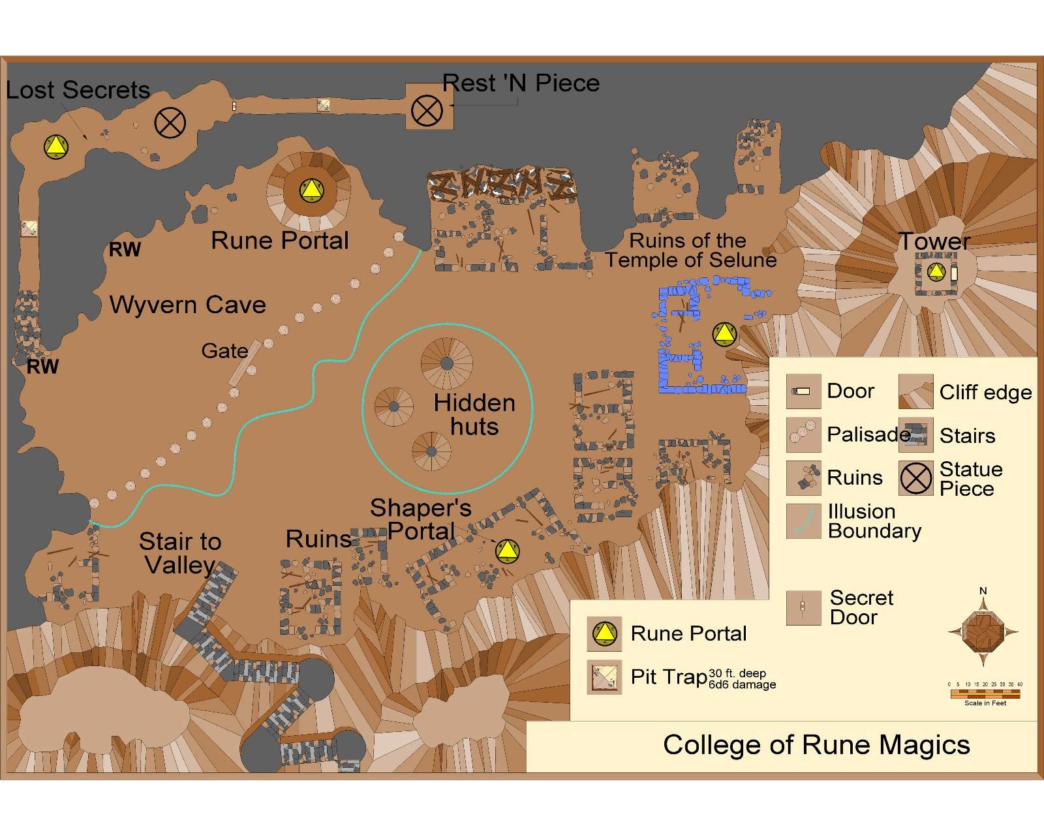

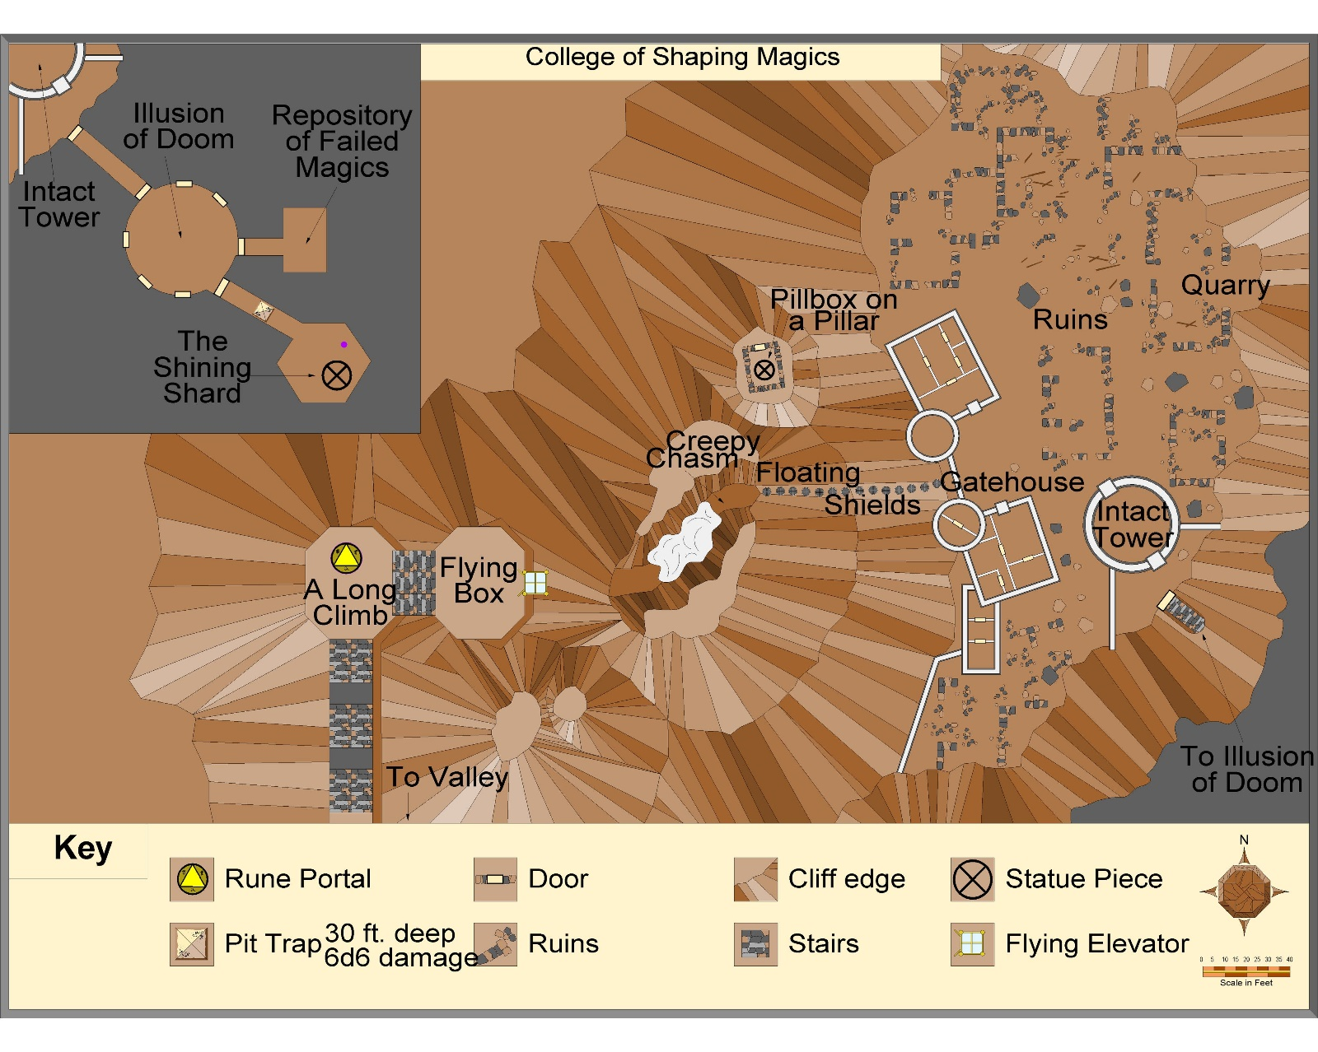

# Hobgoblin camp

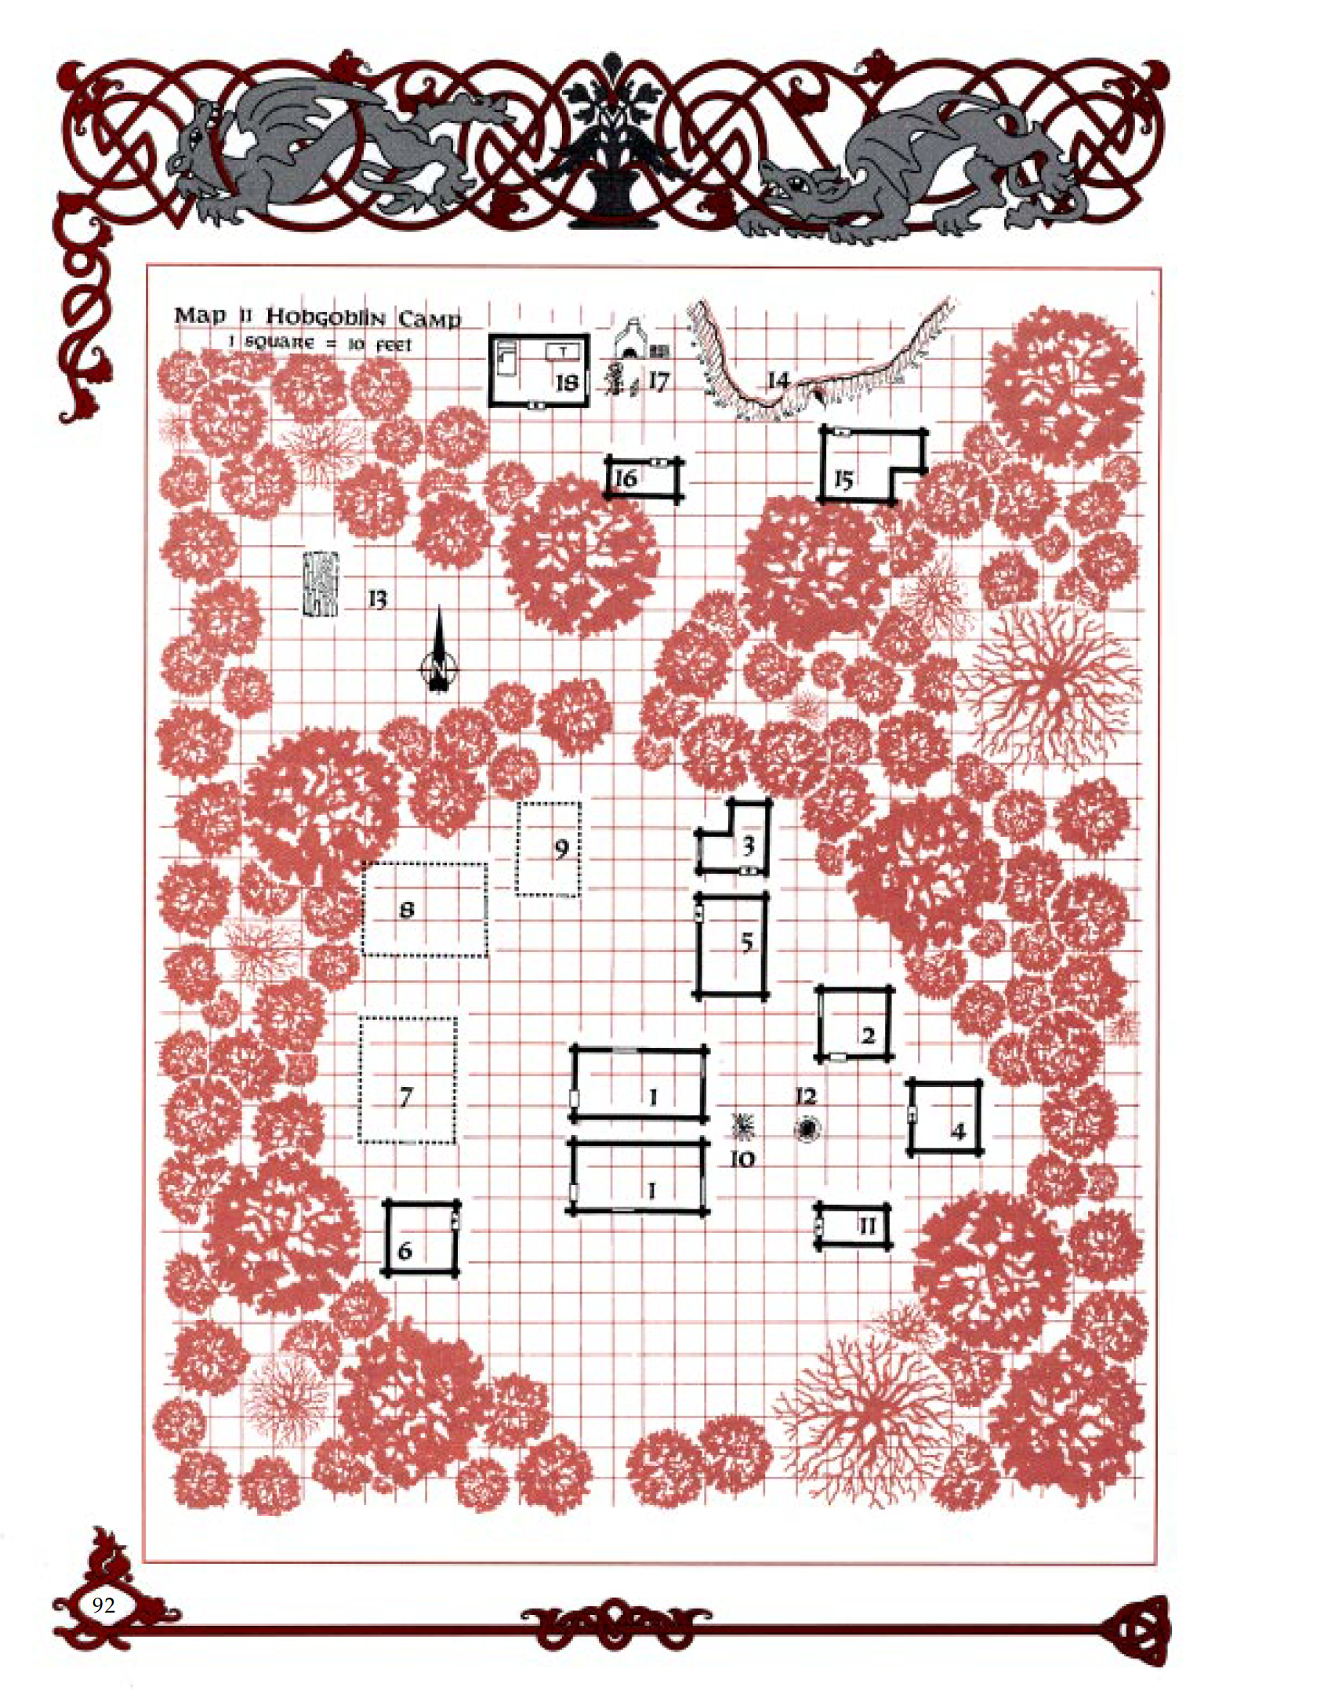

# Организации

## Орден «Братство»

Орден «Братство» состоит из 5 рыцарей и 9 сквайров. Все рыцари и 4 сквайра являются служителями Культа Дракона.

Во главе ячейки стоит:

Культ базируется на постоялом дворе в Thundarlun, таверне в Havenmere.

Также их представитель выкупил магазин в Winterhaven:

#### List of members of Brotherhood

* Andorl
* Ontar
* Halvond
* Roakyn
* Dalandar
* Thol Nordroun
* Vornyn ("Vorn"). Harrowsar
* Wendur Allaghar
* Beliard Halgontar
* Raskival Harbrow
* Foril Moonmantle
* Surgol Dawntard*
* Wend. Steelshorn
* Beltar Harnwood
* Daerent ("Daer") Harrowsar
* Alassra Mallowfaer
* Filfarra Adratha
* Alorae Azmuir
* Raereene Whitewave
* Thornleia Steelhond
* Darlethra Thorntentur
* Claela or Claera Sammurth
* Emsra Ilgund
* Emsra Keskrel
* Thorn Lorthond
* Claela or Claera Ravenwynd

# Encounters in Eastern Cormyr

## Encounters in Forest (Hullack)

## Encounters in Mountains (Thunder Peaks)

1. <http://forums.gleemax.com/showthread.php?t=986999>
2. -- George Krashos
3. According to Tom Costa's sidebar on pg. 9 of the GHotR,
4. https://the-only-one.obsidianportal.com/wikis/thunder-peak-mountains
5.
6. <https://the-only-one.obsidianportal.com/wikis/thunder-peak-mountains>
7. http://forum.candlekeep.com/topic.asp?TOPIC_ID=9685&whichpage=4
8. https://forgottenrealms.fandom.com/wiki/Thundarlun